Welcome and Announcements

PERCEIVING GOD’S GREATNESS

Salutation
Prayer of Invocation and Adoration
*Call to Worship 1 Chronicles 16:9-10
*Song of Worship Hymn #217
Affirmation of Faith The Larger Catechism Question 50
*Song of Worship Psalm 62B

PARALYZED BY GOD’S HOLINESS

Confession of Sin Romans 2:8

Confirmation of the Gospel 1st John 3:23
Song of Worship Hymn #431
**Pastoral Prayer

PURIFIED BY GOD’S WORD & SPIRIT
*Scripture Reading John 15:18-16:33
Sermon “?”
*Song of Response Hymn #519
**The Lord’s Supper

PREPARED BY GOD TO SERVE
*Doxology Psalm 117B
*Benediction Deuteronomy 33:12

“Praise the Lord God, all you nations; all you peoples, sing his praise. For his truth endures forever, and his steadfast love is great. He is faithful!(X2) Hallelujah! Praise the Lord!”

*Congregation standing as able.
** The Lord’s prayer is Heidelberg #119 (Page 894)
**All bread is gluten free.
Welcome and Announcements

PERCEIVING GOD’S GREATNESS

Salutation
Prayer of Invocation and Adoration
*Call to Worship 1 Chronicles 16:9-10
*Song of Worship Hymn #217
Affirmation of Faith The Larger Catechism Question 50
*Song of Worship Psalm 62B

PARALYZED BY GOD’S HOLINESS

Confession of Sin Romans 2:8

Confirmation of the Gospel 1st John 3:23
Song of Worship Hymn #431
**Pastoral Prayer

PURIFIED BY GOD’S WORD & SPIRIT
*Scripture Reading John 15:18-16:33
Sermon “?”
*Song of Response Hymn #519
**The Lord’s Supper

PREPARED BY GOD TO SERVE
*Doxology Psalm 117B
*Benediction Deuteronomy 33:12

“Praise the Lord God, all you nations; all you peoples, sing his praise. For his truth endures forever, and his steadfast love is great. He is faithful!(X2) Hallelujah! Praise the Lord!”

*Congregation standing as able.
** The Lord’s prayer is Heidelberg #119 (Page 894)
**All bread is gluten free.

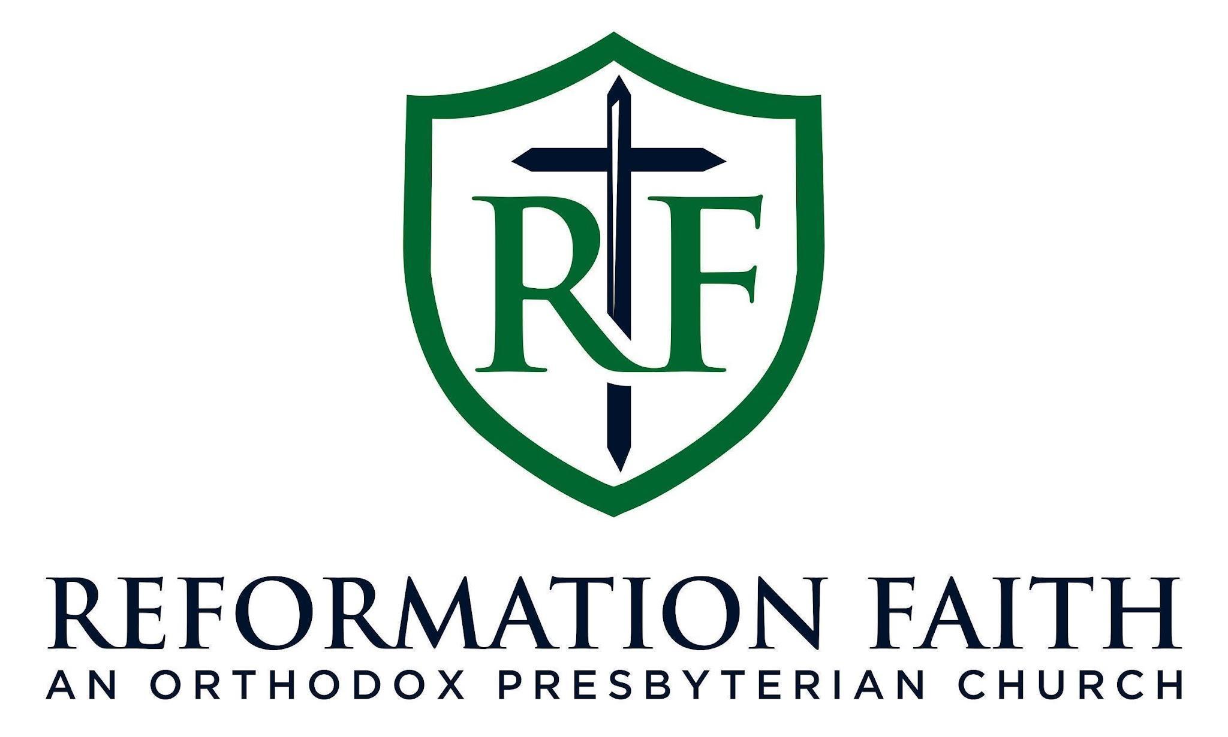

MORNING WORSHIP SERVICE

August 9th , 2026
9:00 A.M.

MORNING WORSHIP SERVICE

August 9th , 2026
9:00 A.M.

