Welcome and Announcements

PERCEIVING OUR GOD’S GREATNESS
Salutation
Prayer of Invocation and Adoration
*Call to Worship 2 Corinthians 2:14

Give thanks to God, who in Christ always leads us in triumphal procession, and through us spreads the fragrance of the knowledge of him everywhere.

*Song of Worship Hymn #213
*Affirmation of Faith Heidelberg #42 (page 879)
*Song of Worship Psalm 36A vv. 1-5

PARALYZED BY GOD’S HOLINESS
Pastoral Prayer
*Song of Worship Psalm 36A vv.6-10

PURIFIED BY GOD’S WORD & SPIRIT
*Scripture Reading Exodus 27
Sermon “In It Together"
*Song of Response Hymn #200

PREPARED BY GOD TO SERVE
*Doxology Hymn #572
*Benediction Numbers 6:24-26

“Praise God from whom all blessings flow,
praise him all creatures here below, alleluia, alleluia
Praise him above ye heavn’ly hosts,
praise Father, Son and Holy Ghost, alleluia, alleluia,
Alleluia, alleluia, alleluia”

*Congregation standing as able.

Welcome and Announcements

PERCEIVING OUR GOD’S GREATNESS
Salutation
Prayer of Invocation and Adoration
*Call to Worship 2 Corinthians 2:14

Give thanks to God, who in Christ always leads us in triumphal procession, and through us spreads the fragrance of the knowledge of him everywhere.

*Song of Worship Hymn #213
*Affirmation of Faith Heidelberg #42 (page 879)
*Song of Worship Psalm 36A vv. 1-5

PARALYZED BY GOD’S HOLINESS
Pastoral Prayer
*Song of Worship Psalm 36A vv.6-10

PURIFIED BY GOD’S WORD & SPIRIT
*Scripture Reading Exodus 27
Sermon “In It Together"
*Song of Response Hymn #200

PREPARED BY GOD TO SERVE
*Doxology Hymn #572
*Benediction Numbers 6:24-26

“Praise God from whom all blessings flow,
praise him all creatures here below, alleluia, alleluia
Praise him above ye heavn’ly hosts,
praise Father, Son and Holy Ghost, alleluia, alleluia,
Alleluia, alleluia, alleluia”

*Congregation standing as able.

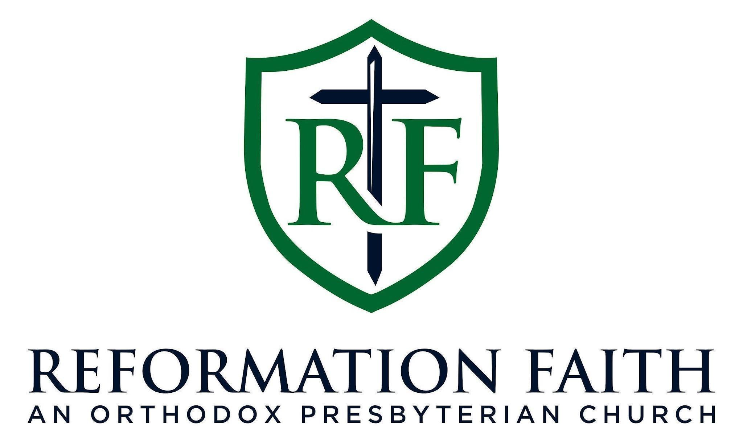

EVENING WORSHIP SERVICE

August 9th, 2026
4:00 P.M.

EVENING WORSHIP SERVICE

August 9th, 2026
4:00 P.M.

