Welcome and Announcements

PERCEIVING GOD’S GREATNESS

Salutation
Prayer of Invocation and Adoration
*Call to Worship Deuteronomy 26:11
*Song of Worship Psalm 111B
Affirmation of Faith The Larger Catechism Question #42
*Song of Worship Hymn #343

PARALYZED BY GOD’S HOLINESS

Confession of Sin Romans 1:31

Confirmation of the Gospel 1 John 2:28-29
Song of Worship Psalm 115A **Pastoral Prayer

PURIFIED BY GOD’S WORD & SPIRIT
*Scripture Reading John 7:1-52
Sermon “Judge with the Right Judgement"
**The Lord’s Supper
*Song of Response Hymn #514

PREPARED BY GOD TO SERVE
*Doxology Psalm 117B
*Benediction Romans 15:33

“Praise the Lord God, all you nations; all you peoples, sing his praise. For his truth endures forever, and his steadfast love is great. He is faithful!(X2) Hallelujah! Praise the Lord!”

*Congregation standing as able.
** The Lord’s prayer is Heidelberg #119 (Page 894)
**All bread is gluten free.

Welcome and Announcements

PERCEIVING GOD’S GREATNESS

Salutation
Prayer of Invocation and Adoration
*Call to Worship Deuteronomy 26:11
*Song of Worship Psalm 111B
Affirmation of Faith The Larger Catechism Question #42
*Song of Worship Hymn #343

PARALYZED BY GOD’S HOLINESS

Confession of Sin Romans 1:31

Confirmation of the Gospel 1 John 2:28-29
Song of Worship Psalm 115A **Pastoral Prayer

PURIFIED BY GOD’S WORD & SPIRIT
*Scripture Reading John 7:1-52
Sermon “Judge with the Right Judgement"
**The Lord’s Supper
*Song of Response Hymn #514

PREPARED BY GOD TO SERVE
*Doxology Psalm 117B
*Benediction Romans 15:33

“Praise the Lord God, all you nations; all you peoples, sing his praise. For his truth endures forever, and his steadfast love is great. He is faithful!(X2) Hallelujah! Praise the Lord!”

*Congregation standing as able.
** The Lord’s prayer is Heidelberg #119 (Page 894)
**All bread is gluten free.

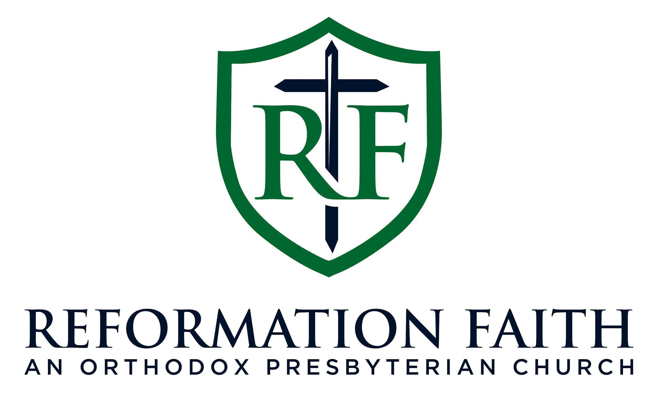

MORNING WORSHIP SERVICE

May 24th , 2026
9:00 A.M.

MORNING WORSHIP SERVICE

May 24th , 2026
9:00 A.M.

