Welcome and Announcements

PERCEIVING GOD’S GREATNESS

*Salutation
*Prayer of Invocation and Adoration
*Call to Worship Deuteronomy 16:11
*Song of Worship Hymn #380
Affirmation of Faith The Larger Catechism Question #39
*Song of Worship Hymn #452

PARALYZED BY GOD’S HOLINESS

Confession of Sin Romans 1:30

Confirmation of the Gospel 1 John 2:23
Song of Worship Psalm 62A **Pastoral Prayer

PURIFIED BY GOD’S WORD & SPIRIT
*Scripture Reading John 5
Sermon “?"
**The Lord’s Supper
*Song of Response Hymn #425

PREPARED BY GOD TO SERVE
*Doxology Psalm 117B
*Benediction Romans 15:5-6

“Praise the Lord God, all you nations; all you peoples, sing his praise. For his truth endures forever, and his steadfast love is great. He is faithful!(X2) Hallelujah! Praise the Lord!”

*Congregation standing as able.
** The Lord’s prayer is Heidelberg #119 (Page 894)
**All bread is gluten free.
Welcome and Announcements

PERCEIVING GOD’S GREATNESS

*Salutation
*Prayer of Invocation and Adoration
*Call to Worship Deuteronomy 16:11
*Song of Worship Hymn #380
Affirmation of Faith The Larger Catechism Question #39
*Song of Worship Hymn #452

PARALYZED BY GOD’S HOLINESS

Confession of Sin Romans 1:30

Confirmation of the Gospel 1 John 2:23
Song of Worship Psalm 62A **Pastoral Prayer

PURIFIED BY GOD’S WORD & SPIRIT
*Scripture Reading John 5
Sermon “?"
**The Lord’s Supper
*Song of Response Hymn #425

PREPARED BY GOD TO SERVE
*Doxology Psalm 117B
*Benediction Romans 15:5-6

“Praise the Lord God, all you nations; all you peoples, sing his praise. For his truth endures forever, and his steadfast love is great. He is faithful!(X2) Hallelujah! Praise the Lord!”

*Congregation standing as able.
** The Lord’s prayer is Heidelberg #119 (Page 894)
**All bread is gluten free.

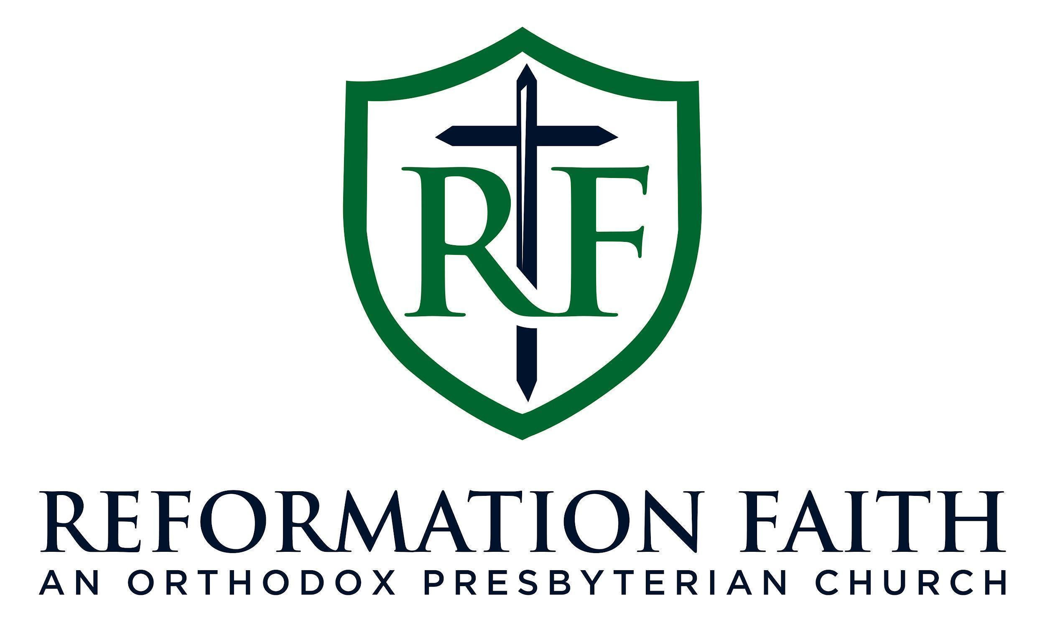

MORNING WORSHIP SERVICE

May 10th , 2026
9:00 A.M.

MORNING WORSHIP SERVICE

May 10th , 2026
9:00 A.M.

