Welcome and Announcements

PERCEIVING OUR GOD’S GREATNESS
Salutation
Prayer of Invocation and Adoration
*Call to Worship Matthew 4:10

It is written, “You shall worship the Lord your
God and him only shall you serve.”

*Song of Worship Psalm 8C
*Affirmation of Faith Heidelberg #31 (page 876)
*Song of Worship Psalm 28

PARALYZED BY GOD’S HOLINESS
Pastoral Prayer
*Song of Worship Psalm 65A

PURIFIED BY GOD’S WORD & SPIRIT
*Scripture Reading Exodus 20:17 Sermon “What God Gives Is Best”
*Song of Response Hymn #256

PREPARED BY GOD TO SERVE
*Doxology Hymn #572
*Benediction Numbers 6:24-26

“Glory be to the Father, and to the Son, and to the Holy Ghost; as it was in the beginning, is now and ever shall be,
world with-out end. Amen, amen.”

*Congregation standing as able.

Welcome and Announcements

PERCEIVING OUR GOD’S GREATNESS
Salutation
Prayer of Invocation and Adoration
*Call to Worship Matthew 4:10

It is written, “You shall worship the Lord your
God and him only shall you serve.”

*Song of Worship Psalm 8C
*Affirmation of Faith Heidelberg #31 (page 876)
*Song of Worship Psalm 28

PARALYZED BY GOD’S HOLINESS
Pastoral Prayer
*Song of Worship Psalm 65A

PURIFIED BY GOD’S WORD & SPIRIT
*Scripture Reading Exodus 20:17 Sermon “What God Gives Is Best”
*Song of Response Hymn #256

PREPARED BY GOD TO SERVE
*Doxology Hymn #572
*Benediction Numbers 6:24-26

“Glory be to the Father, and to the Son, and to the Holy Ghost; as it was in the beginning, is now and ever shall be,
world with-out end. Amen, amen.”

*Congregation standing as able.

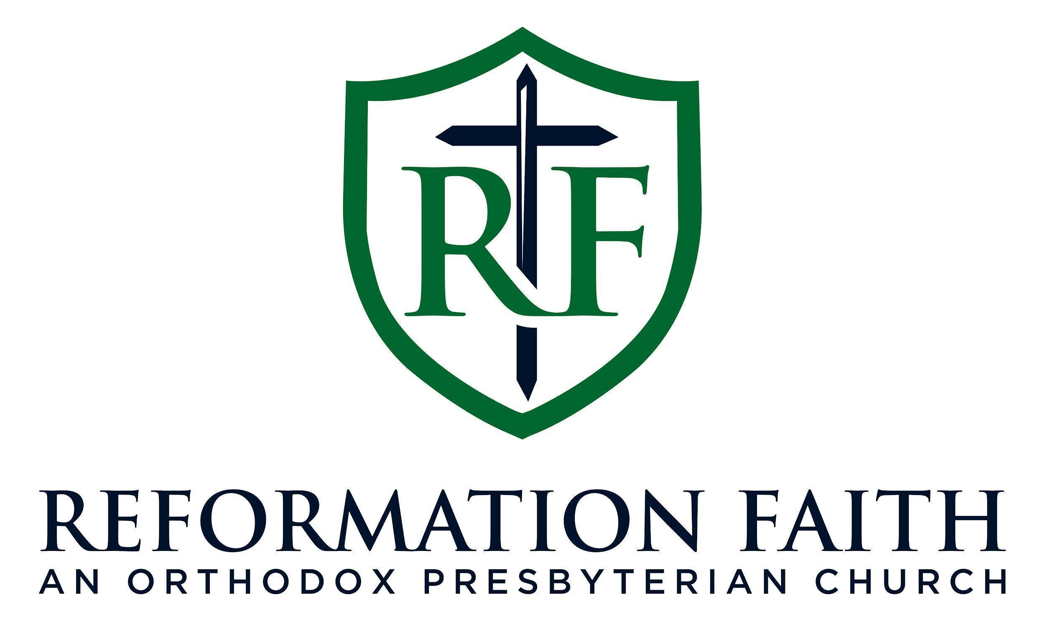

EVENING WORSHIP SERVICE

May 24th, 2026
4:00 P.M.

EVENING WORSHIP SERVICE

May 24th, 2026
4:00 P.M.

