Welcome and Announcements

PERCEIVING GOD’S GREATNESS

*Salutation
*Prayer of Invocation and Adoration
*Call to Worship Deuteronomy 10:14, 2 Peter 3:18
*Song of Worship Hymn #224
Affirmation of Faith The Larger Catechism Question #38
*Song of Worship Hymn # 340

PARALYZED BY GOD’S HOLINESS

Confession of Sin Romans 1:30

Confirmation of the Gospel 1 John 2:17
Song of Worship Psalm 69B **Pastoral Prayer

PURIFIED BY GOD’S WORD & SPIRIT
*Scripture Reading John 4:1-54
Sermon “Drink and Never Thirst Again"
**The Lord’s Supper

PREPARED BY GOD TO SERVE

*Song of Response Hymn #524
*Benediction Numbers 6:24-26
*Doxology Psalm 117B

“Praise the Lord God, all you nations; all you peoples, sing his praise. For his truth endures forever, and his steadfast love is great. He is faithful!(X2) Hallelujah! Praise the Lord!”

*Congregation standing as able.
** The Lord’s prayer is Heidelberg #119 (Page 894)
**All bread is gluten free.
Welcome and Announcements

PERCEIVING GOD’S GREATNESS

*Salutation
*Prayer of Invocation and Adoration
*Call to Worship Deuteronomy 10:14, 2 Peter 3:18
*Song of Worship Hymn #224
Affirmation of Faith The Larger Catechism Question #38
*Song of Worship Hymn # 340

PARALYZED BY GOD’S HOLINESS

Confession of Sin Romans 1:30

Confirmation of the Gospel 1 John 2:17
Song of Worship Psalm 69B **Pastoral Prayer

PURIFIED BY GOD’S WORD & SPIRIT
*Scripture Reading John 4:1-54
Sermon “Drink and Never Thirst Again"
**The Lord’s Supper

PREPARED BY GOD TO SERVE

*Song of Response Hymn #524
*Benediction Numbers 6:24-26
*Doxology Psalm 117B

“Praise the Lord God, all you nations; all you peoples, sing his praise. For his truth endures forever, and his steadfast love is great. He is faithful!(X2) Hallelujah! Praise the Lord!”

*Congregation standing as able.
** The Lord’s prayer is Heidelberg #119 (Page 894)
**All bread is gluten free.

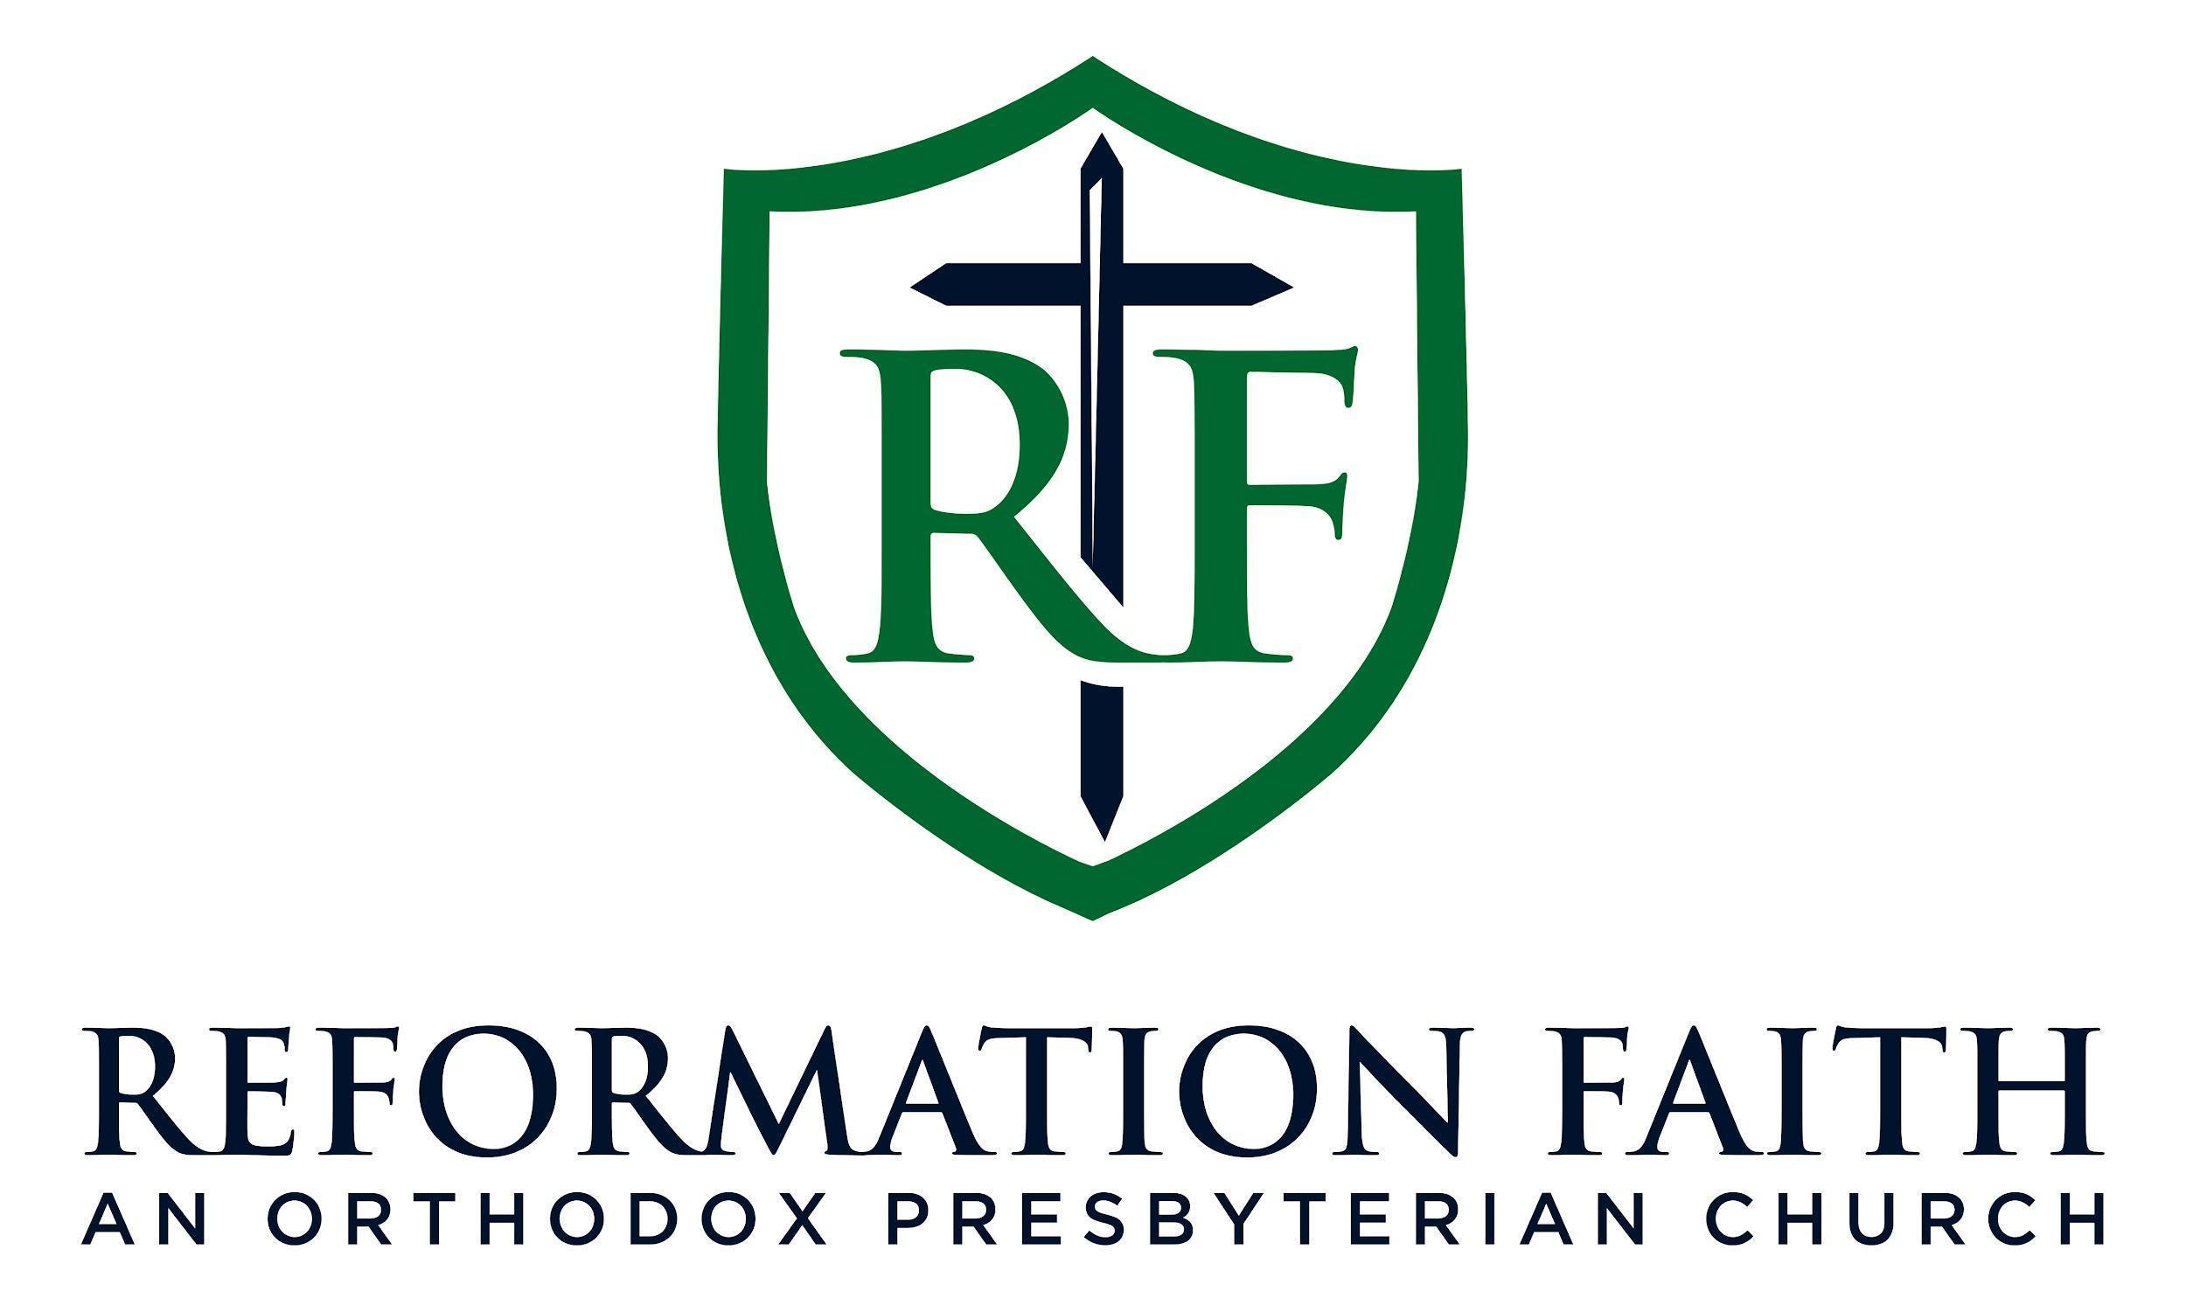

MORNING WORSHIP SERVICE

April 26th , 2026
9:00 A.M.

MORNING WORSHIP SERVICE

April 26th , 2026
9:00 A.M.

