Welcome and Announcements

PERCEIVING GOD’S GREATNESS

*Salutation
*Prayer of Invocation and Adoration
*Call to Worship Deuteronomy 7:6
*Song of Worship Hymn #250
Affirmation of Faith The Larger Catechism Question #37
*Song of Worship Psalm 58

PARALYZED BY GOD’S HOLINESS

Confession of Sin Romans 1:30

Confirmation of the Gospel 1 John 2:13-14
Song of Worship Psalm 71 **Pastoral Prayer

PURIFIED BY GOD’S WORD & SPIRIT
*Scripture Reading John 3:1-36
Sermon “Life From The Spirit"

PREPARED BY GOD TO SERVE

*Song of Response Hymn #526
*Benediction Leviticus 20:26
*Doxology Psalm 117B

“Praise the Lord God, all you nations; all you peoples, sing his praise. For his truth endures forever, and his steadfast love is great. He is faithful!(X2) Hallelujah! Praise the Lord!”

*Congregation standing as able.
** The Lord’s prayer is Heidelberg #119 (Page 894)

Welcome and Announcements

PERCEIVING GOD’S GREATNESS

*Salutation
*Prayer of Invocation and Adoration
*Call to Worship Deuteronomy 7:6
*Song of Worship Hymn #250
Affirmation of Faith The Larger Catechism Question #37
*Song of Worship Psalm 58

PARALYZED BY GOD’S HOLINESS

Confession of Sin Romans 1:30

Confirmation of the Gospel 1 John 2:13-14
Song of Worship Psalm 71 **Pastoral Prayer

PURIFIED BY GOD’S WORD & SPIRIT
*Scripture Reading John 3:1-36
Sermon “Life From The Spirit"

PREPARED BY GOD TO SERVE

*Song of Response Hymn #526
*Benediction Leviticus 20:26
*Doxology Psalm 117B

“Praise the Lord God, all you nations; all you peoples, sing his praise. For his truth endures forever, and his steadfast love is great. He is faithful!(X2) Hallelujah! Praise the Lord!”

*Congregation standing as able.
** The Lord’s prayer is Heidelberg #119 (Page 894)

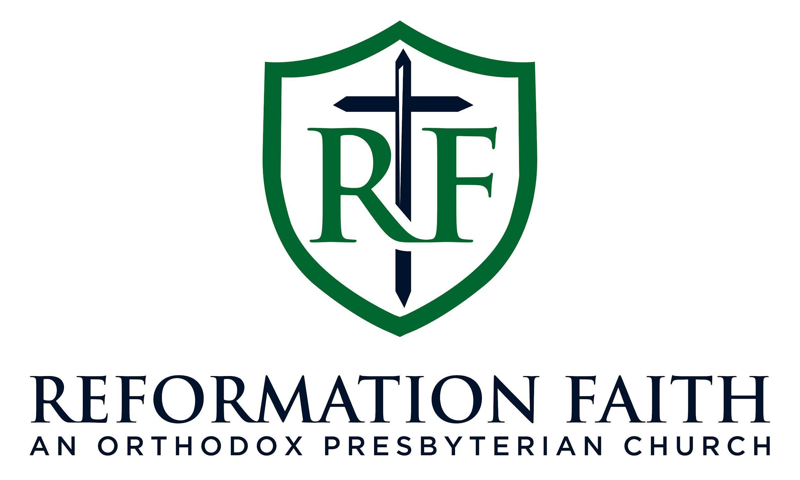

MORNING WORSHIP SERVICE

April 19th , 2026
9:00 A.M.

MORNING WORSHIP SERVICE

April 19th , 2026
9:00 A.M.

