Welcome and Announcements

PERCEIVING GOD’S GREATNESS

*Salutation
*Prayer of Invocation and Adoration
*Call to Worship 1 Peter 1:3, 2:9, Luke 24:34
*Song of Worship Hymn #360
Affirmation of Faith The Apostles’ Creed (page 851)
*Song of Worship Psalm 58

PARALYZED BY GOD’S HOLINESS

Confession of Sin Romans 1:30

Confirmation of the Gospel 1 John 2:4-6
Song of Worship Psalm 77
Pastoral Prayer

PURIFIED BY GOD’S WORD & SPIRIT
*Scripture Reading John 1:19-51
Sermon “The Entourage"

PREPARED BY GOD TO SERVE

*Song of Response Hymn #351
*Benediction Revelation 1:4-5
*Doxology Psalm 117B

“Praise the Lord God, all you nations; all you peoples, sing his praise. For his truth endures forever, and his steadfast love is great. He is faithful!(X2) Hallelujah! Praise the Lord!”

*Congregation standing as able.
** The Lord’s prayer is Heidelberg #119 (Page 894)

Welcome and Announcements

PERCEIVING GOD’S GREATNESS

*Salutation
*Prayer of Invocation and Adoration
*Call to Worship 1 Peter 1:3, 2:9, Luke 24:34
*Song of Worship Hymn #360
Affirmation of Faith The Apostles’ Creed (page 851)
*Song of Worship Psalm 58

PARALYZED BY GOD’S HOLINESS

Confession of Sin Romans 1:30

Confirmation of the Gospel 1 John 2:4-6
Song of Worship Psalm 77
Pastoral Prayer

PURIFIED BY GOD’S WORD & SPIRIT
*Scripture Reading John 1:19-51
Sermon “The Entourage"

PREPARED BY GOD TO SERVE

*Song of Response Hymn #351
*Benediction Revelation 1:4-5
*Doxology Psalm 117B

“Praise the Lord God, all you nations; all you peoples, sing his praise. For his truth endures forever, and his steadfast love is great. He is faithful!(X2) Hallelujah! Praise the Lord!”

*Congregation standing as able.
** The Lord’s prayer is Heidelberg #119 (Page 894)

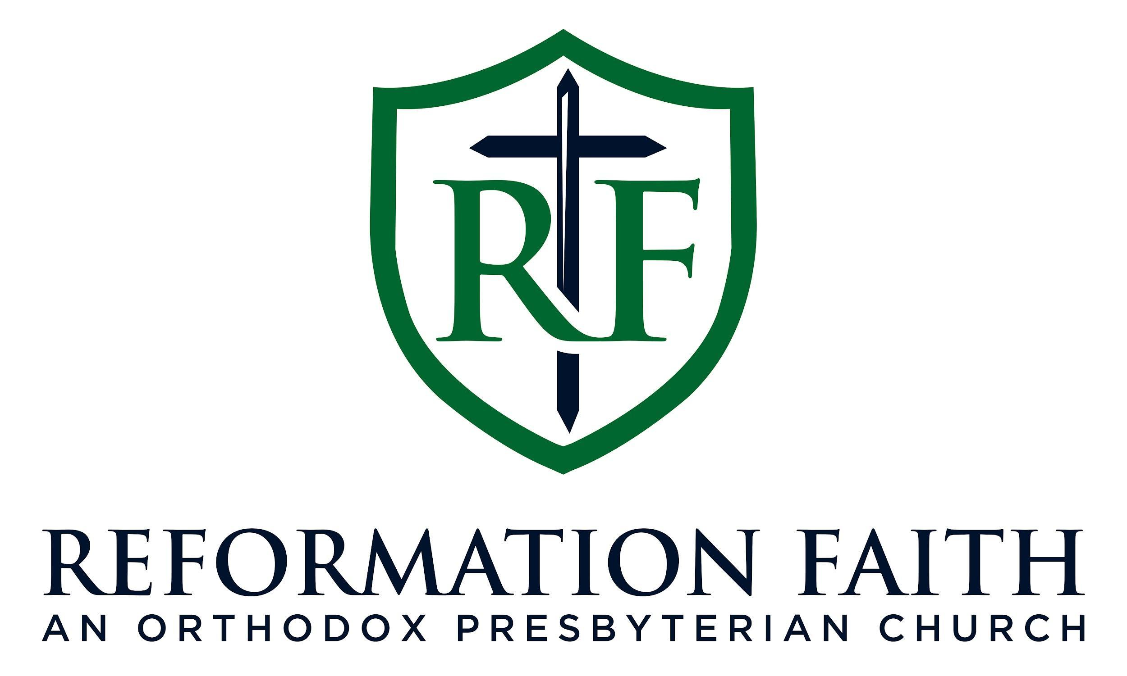

MORNING WORSHIP SERVICE

April 5th , 2026
9:00 A.M.

MORNING WORSHIP SERVICE

April 5th , 2026
9:00 A.M.

