Welcome and Announcements

PERCEIVING OUR GOD’S GREATNESS
*Salutation
*Prayer of Invocation and Adoration
*Call to Worship Joel 2:12,13,15-16,32

“Even now,” declares the Lord, “return to me with all your heart.” Return to the Lord your God, for he is gracious and merciful, slow to anger and abounding in steadfast love. Blow the trumpet in Zion; consecrate a fast;
call a solemn assembly; gather the people.
Consecrate the congregation; assemble the elders, gather the children, even nursing infants. It shall come to pass that everyone who calls on the name of the
Lord shall be saved.

*Song of Worship Hymn #332
*Affirmation of Faith Heidelberg #27 (page 876)
*Song of Worship Psalm 24B

PARALYZED BY GOD’S HOLINESS
Pastoral Prayer
*Song of Worship Psalm 5

PURIFIED BY GOD’S WORD & SPIRIT
*Scripture Reading Exodus 20:13 Sermon “You Shall Not Murder”
PREPARED BY GOD TO SERVE
*Song of Response Hymn #176
*Benediction Numbers 6:24-26
*Doxology Hymn #572

“Glory be to the Father, and to the Son, and to the Holy Ghost; as it was in the beginning, is now and ever shall be,
world with-out end. Amen, amen.”

*Congregation standing as able.
Welcome and Announcements

PERCEIVING OUR GOD’S GREATNESS
*Salutation
*Prayer of Invocation and Adoration
*Call to Worship Joel 2:12,13,15-16,32

“Even now,” declares the Lord, “return to me with all your heart.” Return to the Lord your God, for he is gracious and merciful, slow to anger and abounding in steadfast love. Blow the trumpet in Zion; consecrate a fast;
call a solemn assembly; gather the people.
Consecrate the congregation; assemble the elders, gather the children, even nursing infants. It shall come to pass that everyone who calls on the name of the
Lord shall be saved.

*Song of Worship Hymn #332
*Affirmation of Faith Heidelberg #27 (page 876)
*Song of Worship Psalm 24B

PARALYZED BY GOD’S HOLINESS
Pastoral Prayer
*Song of Worship Psalm 5

PURIFIED BY GOD’S WORD & SPIRIT
*Scripture Reading Exodus 20:13 Sermon “You Shall Not Murder”
PREPARED BY GOD TO SERVE
*Song of Response Hymn #176
*Benediction Numbers 6:24-26
*Doxology Hymn #572

“Glory be to the Father, and to the Son, and to the Holy Ghost; as it was in the beginning, is now and ever shall be,
world with-out end. Amen, amen.”

*Congregation standing as able.

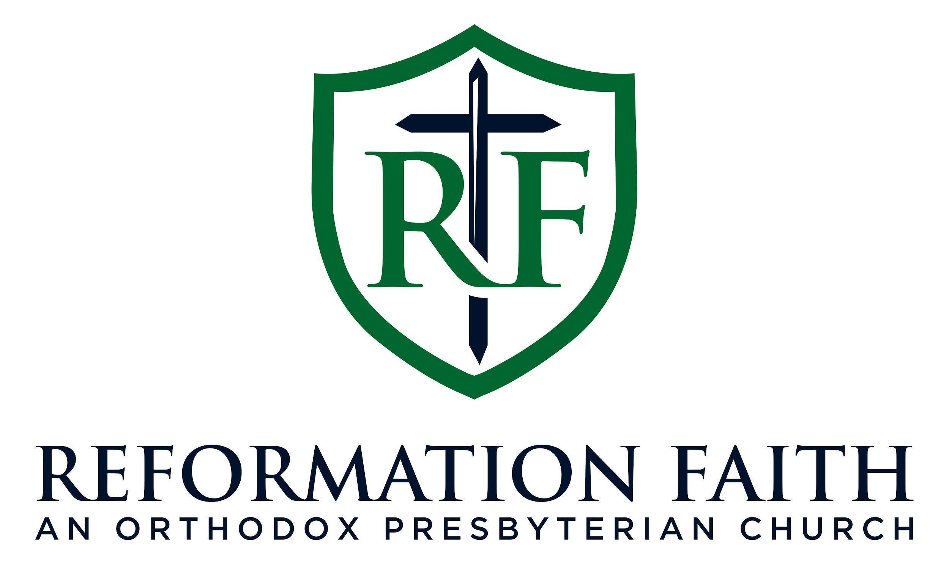

EVENING WORSHIP SERVICE

April 26th, 2026
4:00 P.M.

EVENING WORSHIP SERVICE

April 26th, 2026
4:00 P.M.

