Welcome and Announcements

PERCEIVING OUR GOD’S GREATNESS
*Salutation
*Prayer of Invocation and Adoration
*Call to Worship Daniel 7:13, 14

In Daniel’s vision, he saw coming with the clouds of heaven one like a son of man. And to him was given dominion and glory and a kingdom, that all peoples, nations, and languages should serve him

*Song of Worship Hymn #249
*Affirmation of Faith Heidelberg #26 (page 876)
*Song of Worship Psalm 23A

PARALYZED BY GOD’S HOLINESS
*Song of Worship Psalm 4
Pastoral Prayer

PURIFIED BY GOD’S WORD & SPIRIT
*Scripture Reading Exodus 20:12 Sermon “Order and Honor”
**The Lord’s Supper

PREPARED BY GOD TO SERVE
*Song of Response Hymn #447
*Benediction Numbers 6:24-26
*Doxology Hymn #572

“Glory be to the Father, and to the Son, and to the Holy Ghost; as it was in the beginning, is now and ever shall be,
world with-out end. Amen, amen.”

*Congregation standing as able.
**All bread is gluten free.
Welcome and Announcements

PERCEIVING OUR GOD’S GREATNESS
*Salutation
*Prayer of Invocation and Adoration
*Call to Worship Daniel 7:13, 14

In Daniel’s vision, he saw coming with the clouds of heaven one like a son of man. And to him was given dominion and glory and a kingdom, that all peoples, nations, and languages should serve him

*Song of Worship Hymn #249
*Affirmation of Faith Heidelberg #26 (page 876)
*Song of Worship Psalm 23A

PARALYZED BY GOD’S HOLINESS
*Song of Worship Psalm 4
Pastoral Prayer

PURIFIED BY GOD’S WORD & SPIRIT
*Scripture Reading Exodus 20:12 Sermon “Order and Honor”
**The Lord’s Supper

PREPARED BY GOD TO SERVE
*Song of Response Hymn #447
*Benediction Numbers 6:24-26
*Doxology Hymn #572

“Glory be to the Father, and to the Son, and to the Holy Ghost; as it was in the beginning, is now and ever shall be,
world with-out end. Amen, amen.”

*Congregation standing as able.
**All bread is gluten free.

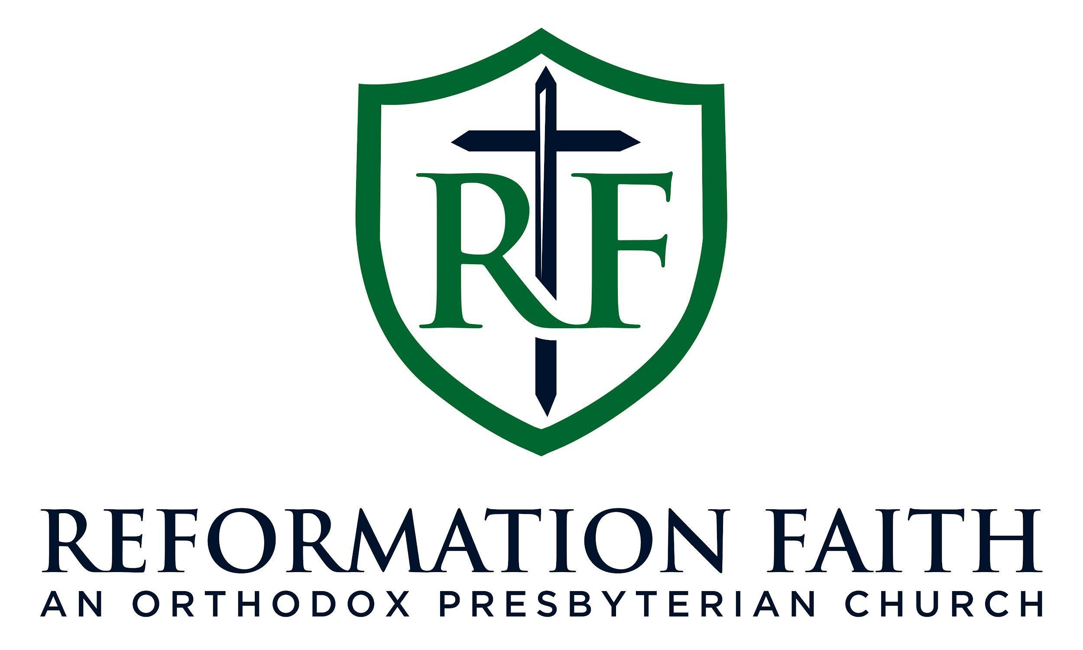

EVENING WORSHIP SERVICE

April 19th, 2026
4:00 P.M.

EVENING WORSHIP SERVICE

April 19th, 2026
4:00 P.M.

