Welcome and Announcements

PERCEIVING OUR GOD’S GREATNESS
*Salutation
*Prayer of Invocation and Adoration
*Call to Worship Ezekiel 20:40-41, 20:42

The Lord God requires your contributions and the choicest of your gifts, with all your sacred offerings. As a pleasing aroma he will accept you, and you shall know
that he is the Lord.

*Song of Worship Hymn #374
*Affirmation of Faith Heidelberg #24 (page 875)
*Song of Worship Psalm 21A

PARALYZED BY GOD’S HOLINESS
*Song of Worship Psalm 2
Pastoral Prayer

PURIFIED BY GOD’S WORD & SPIRIT
*Scripture Reading Exodus 20:8-11
Sermon “Strive to Rest”
**The Lord’s Supper

PREPARED BY GOD TO SERVE
*Song of Response Hymn #408
*Benediction Numbers 6:24-26
*Doxology Psalm 117B

“Praise the Lord God, all you nations; all you peoples, sing his praise. For his truth endures forever, and his steadfast love is great. He is faithful!(X2) Hallelujah! Praise the Lord!”

*Congregation standing as able.
**All bread is gluten free.
Welcome and Announcements

PERCEIVING OUR GOD’S GREATNESS
*Salutation
*Prayer of Invocation and Adoration
*Call to Worship Ezekiel 20:40-41, 20:42

The Lord God requires your contributions and the choicest of your gifts, with all your sacred offerings. As a pleasing aroma he will accept you, and you shall know
that he is the Lord.

*Song of Worship Hymn #374
*Affirmation of Faith Heidelberg #24 (page 875)
*Song of Worship Psalm 21A

PARALYZED BY GOD’S HOLINESS
*Song of Worship Psalm 2
Pastoral Prayer

PURIFIED BY GOD’S WORD & SPIRIT
*Scripture Reading Exodus 20:8-11
Sermon “Strive to Rest”
**The Lord’s Supper

PREPARED BY GOD TO SERVE
*Song of Response Hymn #408
*Benediction Numbers 6:24-26
*Doxology Psalm 117B

“Praise the Lord God, all you nations; all you peoples, sing his praise. For his truth endures forever, and his steadfast love is great. He is faithful!(X2) Hallelujah! Praise the Lord!”

*Congregation standing as able.
**All bread is gluten free.

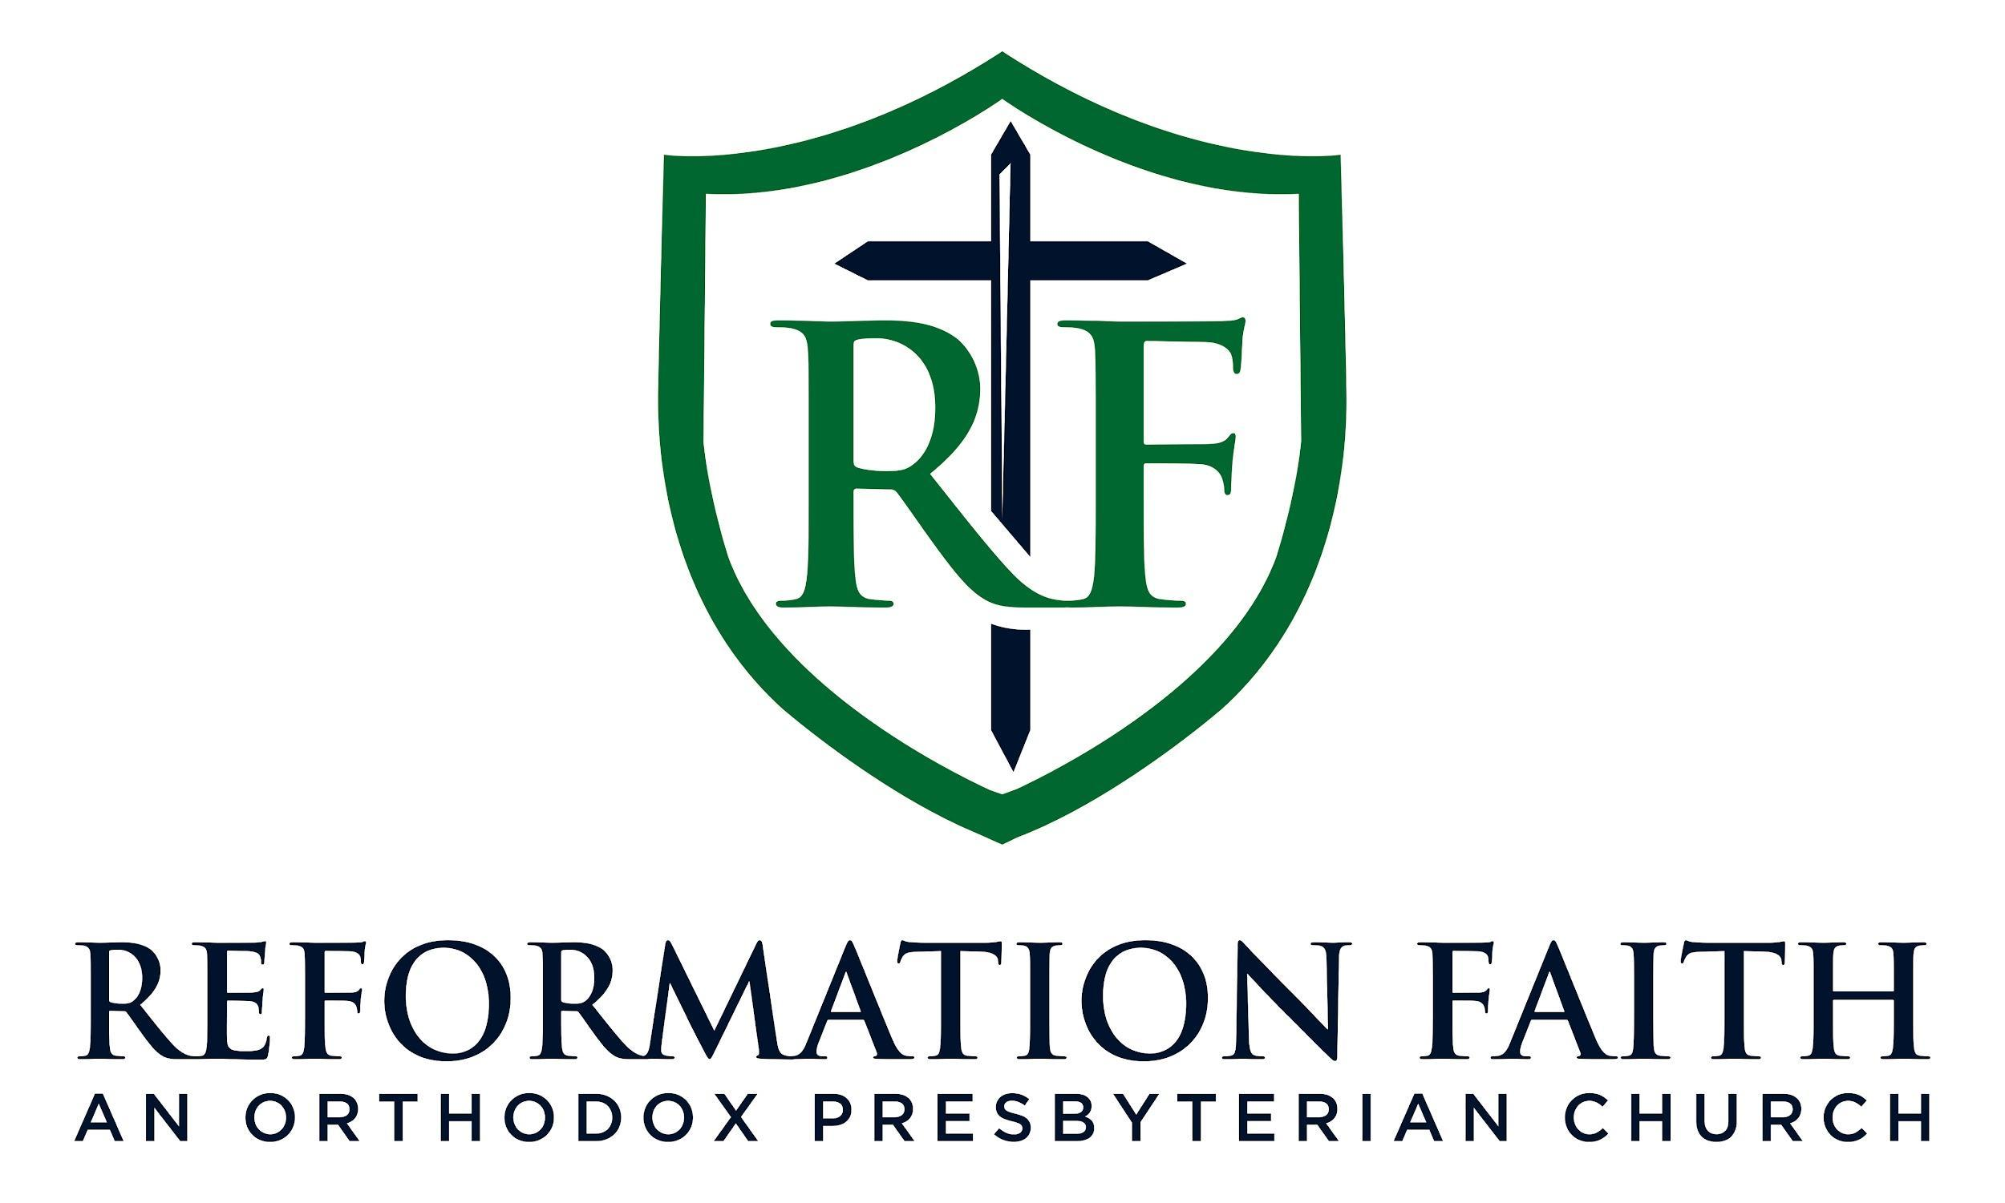

EVENING WORSHIP SERVICE

April 5th, 2026
4:00 P.M.

EVENING WORSHIP SERVICE

April 5th, 2026
4:00 P.M.

