Welcome and Announcements

PERCEIVING GOD’S GREATNESS

*Salutation
*Prayer of Invocation and Adoration
*Call to Worship Deuteronomy 4:36-39
*Song of Worship Hymn #230
Affirmation of Faith The Larger Catechism Question #30
*Song of Worship Hymn #265

PARALYZED BY GOD’S HOLINESS

Confession of Sin Romans 1:28-29

Confirmation of the Gospel 1 John 1:9
Song of Worship Psalm 79A
Pastoral Prayer

PURIFIED BY GOD’S WORD & SPIRIT
*Scripture Reading Exodus 19:16-25
Sermon “The Cloud and Fire”
**The Lord’s Supper

PREPARED BY GOD TO SERVE

*Song of Response Hymn #446
*Benediction 2nd Corinthians 9:10
*Doxology Psalm 117B

“Praise the Lord God, all you nations; all you peoples, sing his praise. For his truth endures forever, and his steadfast love is great. He is faithful!(X2) Hallelujah! Praise the Lord!”

*Congregation standing as able.
** The Lord’s prayer is Heidelberg #119 (Page 894)
**All bread is gluten free.
Welcome and Announcements

PERCEIVING GOD’S GREATNESS

*Salutation
*Prayer of Invocation and Adoration
*Call to Worship Deuteronomy 4:36-39
*Song of Worship Hymn #230
Affirmation of Faith The Larger Catechism Question #30
*Song of Worship Hymn #265

PARALYZED BY GOD’S HOLINESS

Confession of Sin Romans 1:28-29

Confirmation of the Gospel 1 John 1:9
Song of Worship Psalm 79A
Pastoral Prayer

PURIFIED BY GOD’S WORD & SPIRIT
*Scripture Reading Exodus 19:16-25
Sermon “The Cloud and Fire”
**The Lord’s Supper

PREPARED BY GOD TO SERVE

*Song of Response Hymn #446
*Benediction 2nd Corinthians 9:10
*Doxology Psalm 117B

“Praise the Lord God, all you nations; all you peoples, sing his praise. For his truth endures forever, and his steadfast love is great. He is faithful!(X2) Hallelujah! Praise the Lord!”

*Congregation standing as able.
** The Lord’s prayer is Heidelberg #119 (Page 894)
**All bread is gluten free.

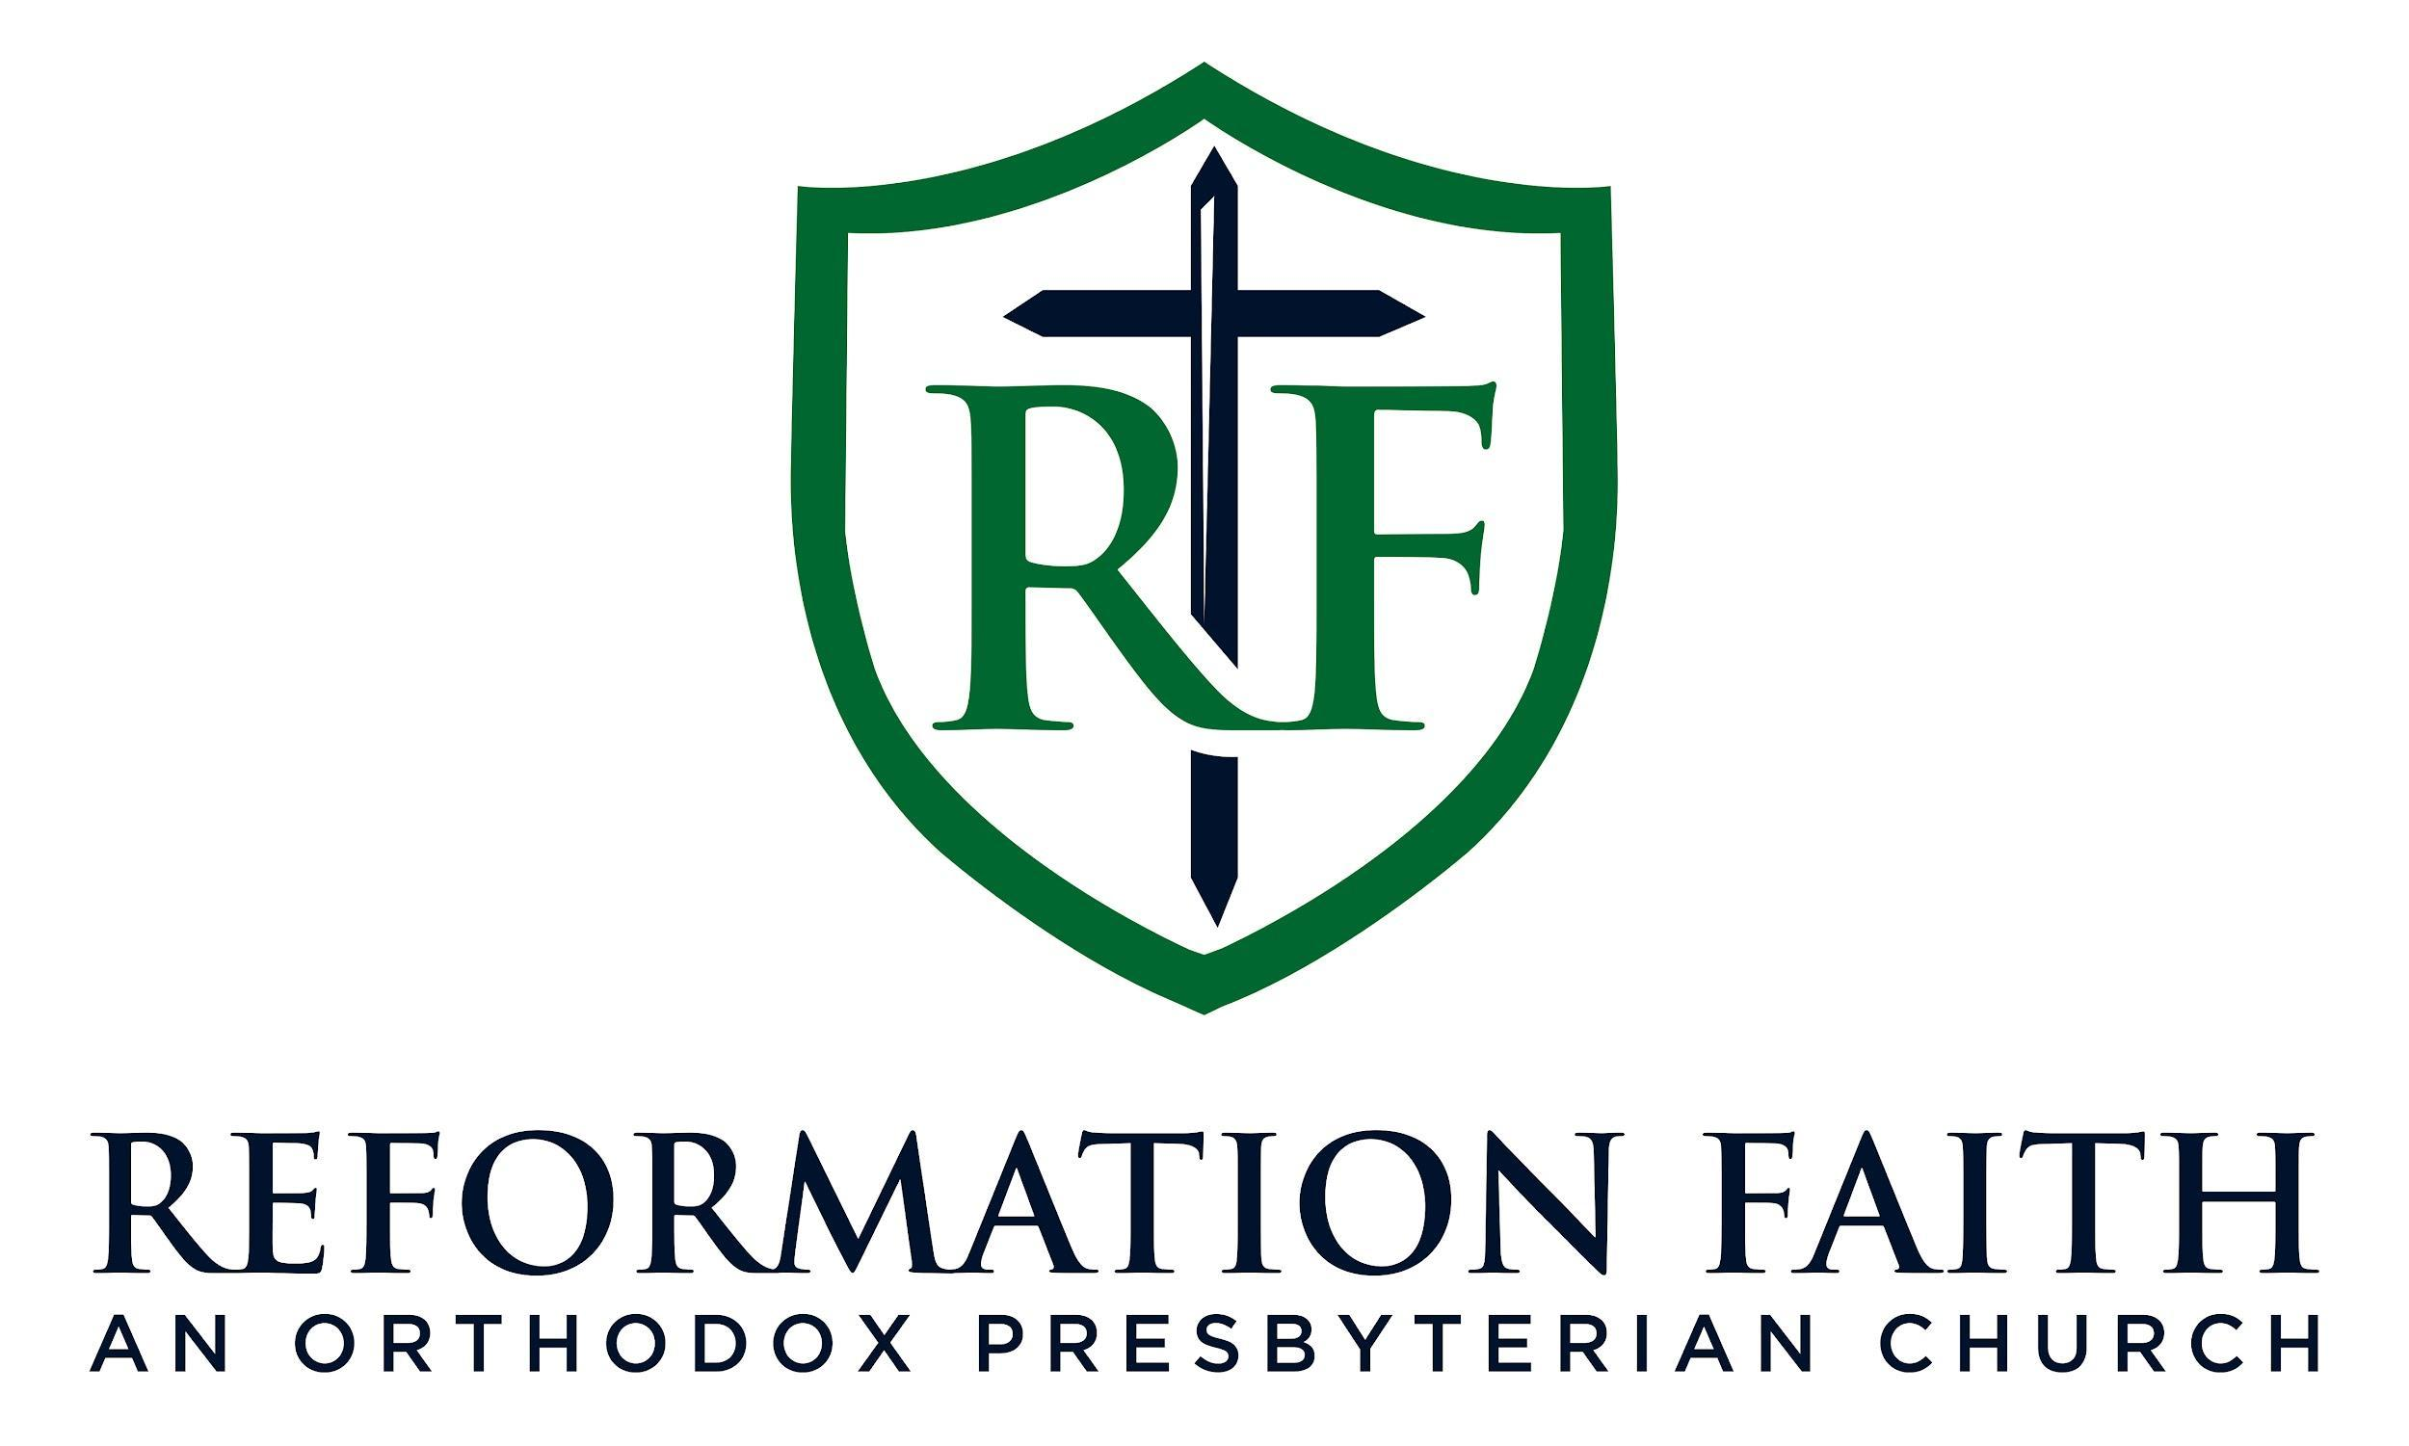

MORNING WORSHIP SERVICE

March 8th, 2026 9:00 A.M.

MORNING WORSHIP SERVICE

March 8th, 2026 9:00 A.M.

