Welcome and Announcements

PERCEIVING GOD’S GREATNESS

*Salutation
*Prayer of Invocation and Adoration
*Call to Worship Deuteronomy 4:29
*Song of Worship Hymn #216
Affirmation of Faith The Apostles Creed (page 851)
*Song of Worship Psalm 56

PARALYZED BY GOD’S HOLINESS

Confession of Sin Romans 1:28-29

Confirmation of the Gospel 1 John 1:7
Song of Worship Psalm 80B
Pastoral Prayer

PURIFIED BY GOD’S WORD & SPIRIT
*Scripture Reading Exodus 19:1-5 Sermon “A Religious Upgrade”

PREPARED BY GOD TO SERVE

*Song of Response Hymn #425
*Benediction Jeremiah 31:11-14
*Doxology Psalm 117B

“Praise the Lord God, all you nations; all you peoples, sing his praise. For his truth endures forever, and his steadfast love is great. He is faithful!(X2) Hallelujah! Praise the Lord!”

*Congregation standing as able.
** The Lord’s prayer is Heidelberg #119 (Page 894)

Welcome and Announcements

PERCEIVING GOD’S GREATNESS

*Salutation
*Prayer of Invocation and Adoration
*Call to Worship Deuteronomy 4:29
*Song of Worship Hymn #216
Affirmation of Faith The Apostles Creed (page 851)
*Song of Worship Psalm 56

PARALYZED BY GOD’S HOLINESS

Confession of Sin Romans 1:28-29

Confirmation of the Gospel 1 John 1:7
Song of Worship Psalm 80B
Pastoral Prayer

PURIFIED BY GOD’S WORD & SPIRIT
*Scripture Reading Exodus 19:1-5 Sermon “A Religious Upgrade”

PREPARED BY GOD TO SERVE

*Song of Response Hymn #425
*Benediction Jeremiah 31:11-14
*Doxology Psalm 117B

“Praise the Lord God, all you nations; all you peoples, sing his praise. For his truth endures forever, and his steadfast love is great. He is faithful!(X2) Hallelujah! Praise the Lord!”

*Congregation standing as able.
** The Lord’s prayer is Heidelberg #119 (Page 894)

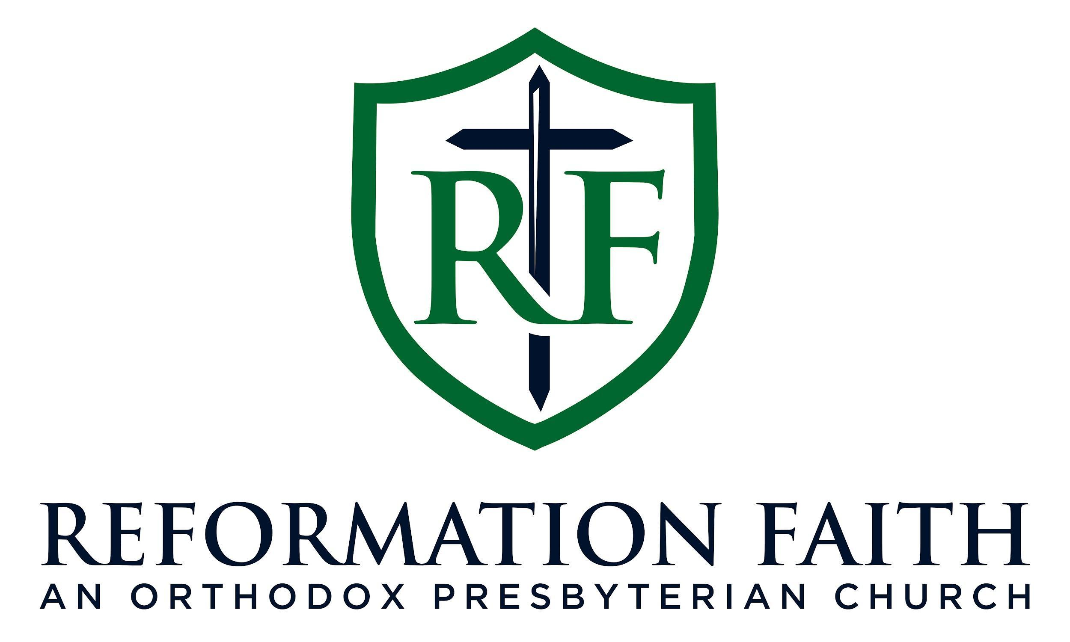

MORNING WORSHIP SERVICE

March 1st, 2026 9:00 A.M.

MORNING WORSHIP SERVICE

March 1st, 2026 9:00 A.M.

