Welcome and Announcements

PERCEIVING OUR GOD’S GREATNESS
*Salutation
*Prayer of Invocation and Adoration
*Call to Worship Jeremiah 17:24

“Listen to me,” declares the Lord, “and bring in no burden on the Sabbath day, but keep the Sabbath holy and bring thank offerings to the house of the Lord”

*Song of Worship Hymn #288
*Affirmation of Faith Heidelberg #20 (page 875)
*Song of Worship Psalm 18

PARALYZED BY GOD’S HOLINESS

Confession of Sin Deuteronomy 5:19

Confirmation of the Gospel Phillipians 1:22-26
*Song of Worship Psalm 145B
Pastoral Prayer

PURIFIED BY GOD’S WORD & SPIRIT
*Scripture Reading 1st Kings 19:19-21
Sermon Guest preacher Rev. Ben Hopp
“When You Are All Alone Where Do You Go For Help?”

PREPARED BY GOD TO SERVE
*Song of Response Hymn #540
*Benediction Numbers 6:24-26
*Doxology Psalm 117B

“Praise the Lord God, all you nations; all you peoples, sing his praise. For his truth endures forever, and his steadfast love is great. He is faithful!(X2) Hallelujah! Praise the Lord!”

*Congregation standing as able.

Welcome and Announcements

PERCEIVING OUR GOD’S GREATNESS
*Salutation
*Prayer of Invocation and Adoration
*Call to Worship Jeremiah 17:24

“Listen to me,” declares the Lord, “and bring in no burden on the Sabbath day, but keep the Sabbath holy and bring thank offerings to the house of the Lord”

*Song of Worship Hymn #288
*Affirmation of Faith Heidelberg #20 (page 875)
*Song of Worship Psalm 18

PARALYZED BY GOD’S HOLINESS

Confession of Sin Deuteronomy 5:19

Confirmation of the Gospel Phillipians 1:22-26
*Song of Worship Psalm 145B
Pastoral Prayer

PURIFIED BY GOD’S WORD & SPIRIT
*Scripture Reading 1st Kings 19:19-21
Sermon Guest preacher Rev. Ben Hopp
“When You Are All Alone Where Do You Go For Help?”

PREPARED BY GOD TO SERVE
*Song of Response Hymn #540
*Benediction Numbers 6:24-26
*Doxology Psalm 117B

“Praise the Lord God, all you nations; all you peoples, sing his praise. For his truth endures forever, and his steadfast love is great. He is faithful!(X2) Hallelujah! Praise the Lord!”

*Congregation standing as able.

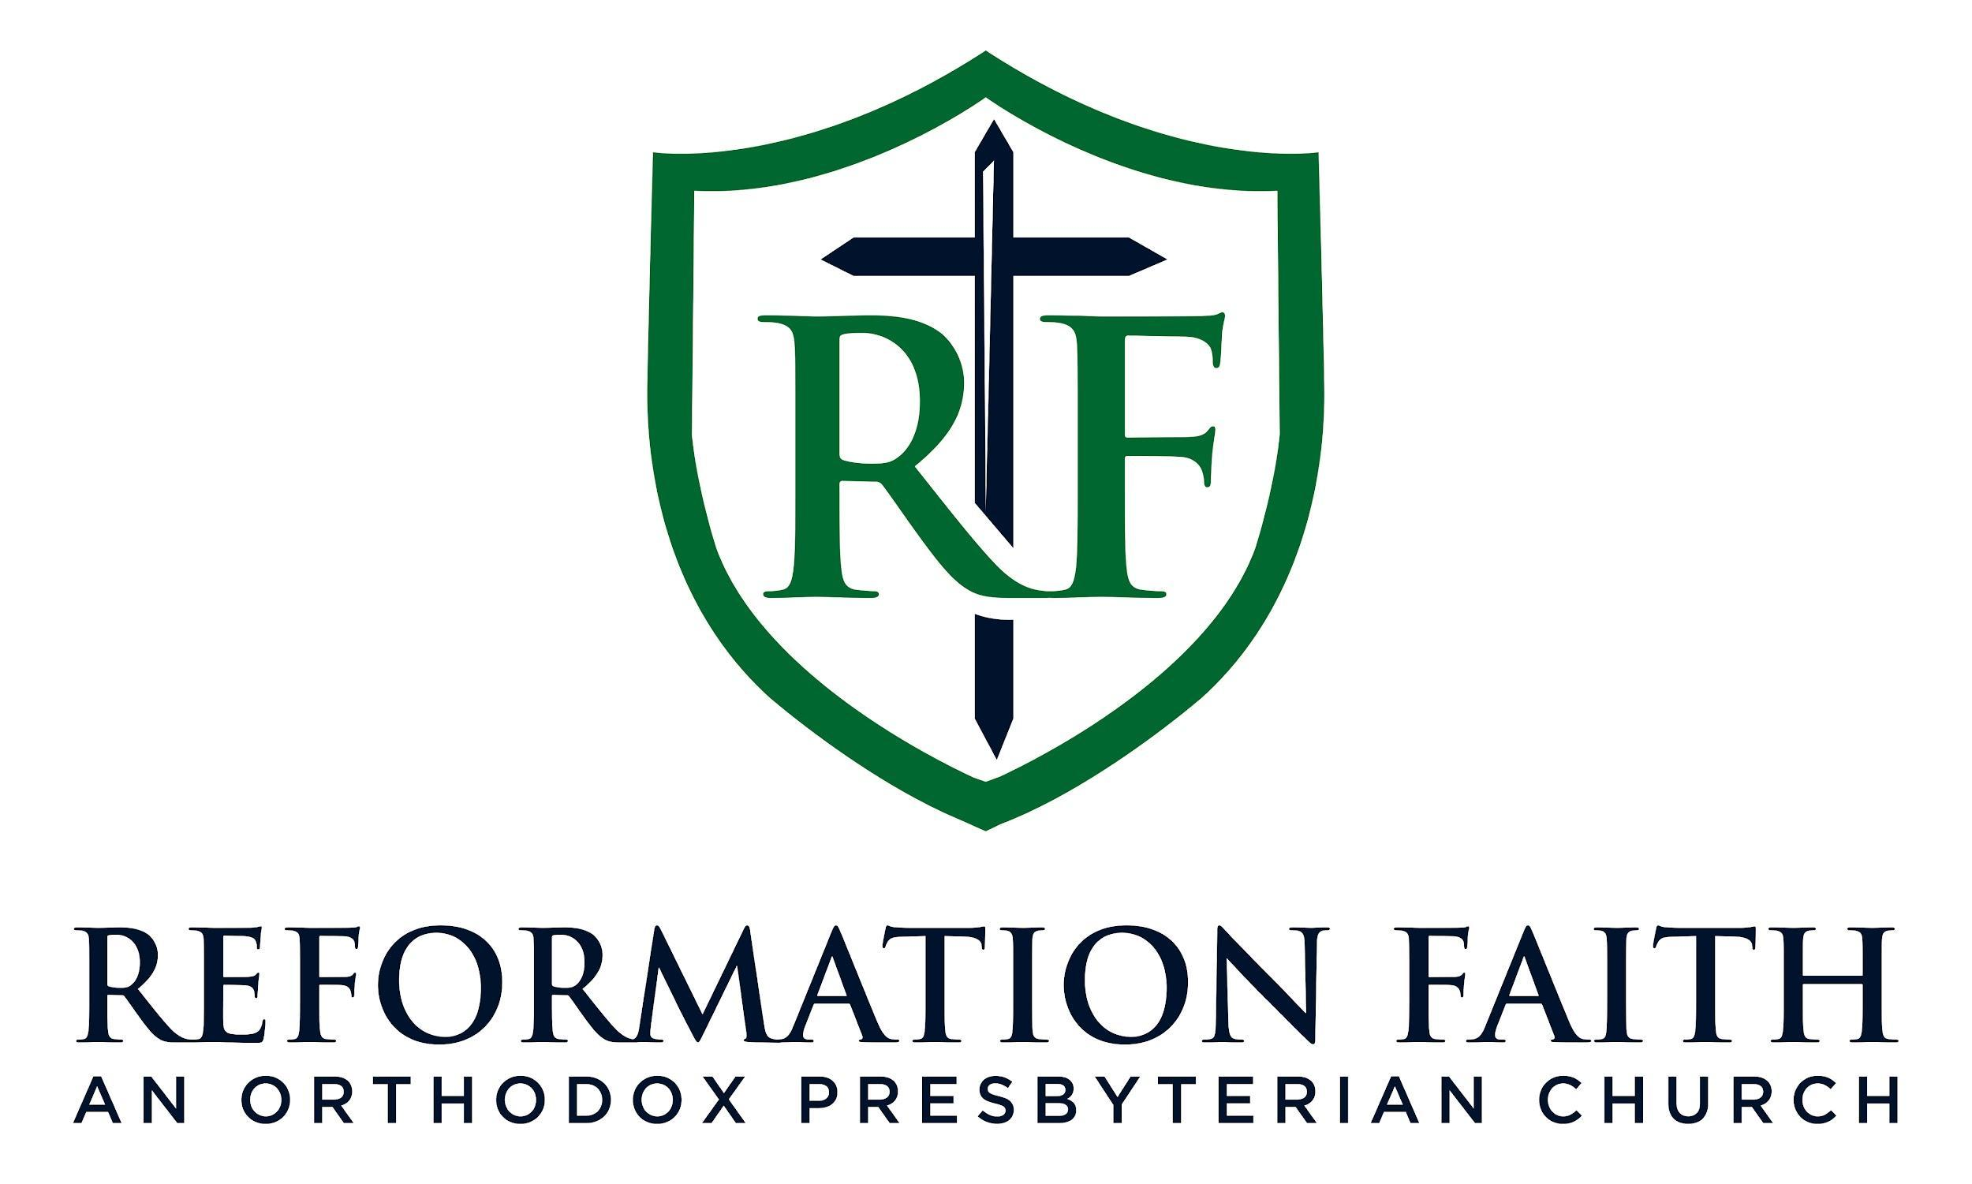

EVENING WORSHIP SERVICE

March 8th, 2026
4:00 P.M.

EVENING WORSHIP SERVICE

March 8th, 2026
4:00 P.M.

