Welcome and Announcements

PERCEIVING GOD’S GREATNESS

*Salutation
*Prayer of Invocation and Adoration
*Call to Worship Exodus 15:13, 1 Chronicles 16:29
*Song of Worship Hymn #463
Affirmation of Faith The Larger Catechism Question 26
*Song of Worship Hymn #276

PARALYZED BY GOD’S HOLINESS

Confession of Sin Romans 1:24-25

Confirmation of the Gospel Romans 9:5
Song of Worship Psalm 90A
**Pastoral Prayer with the Lord’s Prayer

PURIFIED BY GOD’S WORD & SPIRIT
*Scripture Reading Exodus 15
Sermon “A Song For The Lord”

PREPARED BY GOD TO SERVE

*Song of Response Hymn #459
Baptism of Jacob Privette
Receiving New Members and Vows
*Benediction Deuteronomy 30:9-10
*Doxology Psalm 117B

“Praise the Lord God, all you nations; all you peoples, sing his praise. For his truth endures forever, and his steadfast love is great. He is faithful!(X2) Hallelujah! Praise the Lord!”

*Congregation standing as able.
** The Lord’s prayer is Heidelberg #119 (Page 894)
Welcome and Announcements

PERCEIVING GOD’S GREATNESS

*Salutation
*Prayer of Invocation and Adoration
*Call to Worship Exodus 15:13, 1 Chronicles 16:29
*Song of Worship Hymn #463
Affirmation of Faith The Larger Catechism Question 26
*Song of Worship Hymn #276

PARALYZED BY GOD’S HOLINESS

Confession of Sin Romans 1:24-25

Confirmation of the Gospel Romans 9:5
Song of Worship Psalm 90A
Pastoral Prayer with the Lord’s Prayer

PURIFIED BY GOD’S WORD & SPIRIT
*Scripture Reading Exodus 15
Sermon “A Song For The Lord”

PREPARED BY GOD TO SERVE

*Song of Response Hymn #459
Baptism of Jacob Privette
Receiving New Members and Vows
*Benediction Deuteronomy 30:9-10
*Doxology Psalm 117B

“Praise the Lord God, all you nations; all you peoples, sing his praise. For his truth endures forever, and his steadfast love is great. He is faithful!(X2) Hallelujah! Praise the Lord!”

*Congregation standing as able.
** The Lord’s prayer is Heidelberg #119 (Page 894)

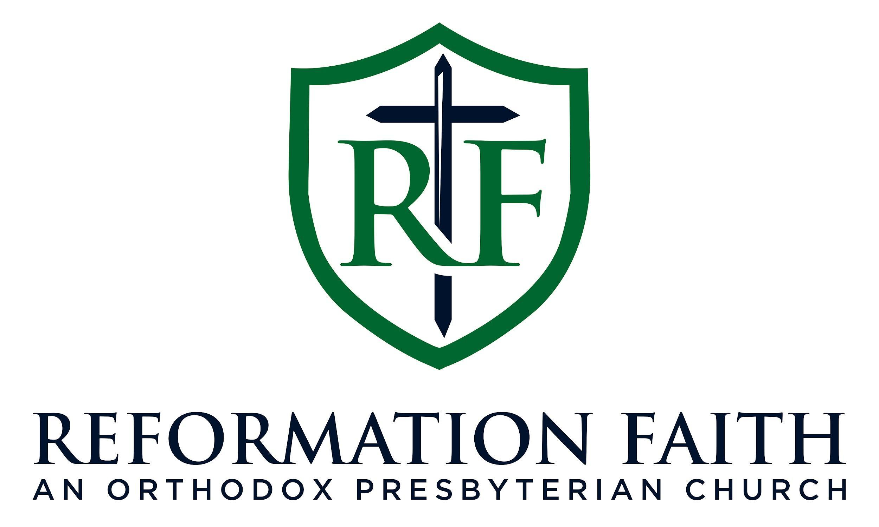

MORNING WORSHIP SERVICE

January 25th, 2026 9:00 A.M.

MORNING WORSHIP SERVICE

January 25th, 2026 9:00 A.M.

