Welcome and Announcements

PERCEIVING GOD’S GREATNESS

*Salutation
*Prayer of Invocation and Adoration
*Call to Worship Exodus 15:1-2
*Song of Worship Hymn #552
Affirmation of Faith The Larger Catechism Question 25
*Song of Worship Psalm 55

PARALYZED BY GOD’S HOLINESS

Confession of Sin Romans 1:23

Confirmation of the Gospel Acts 17:29-31
Song of Worship Psalm 91B
Pastoral Prayer

PURIFIED BY GOD’S WORD & SPIRIT
*Scripture Reading Exodus 14
Sermon “Who’s Trapped Now?”

PREPARED BY GOD TO SERVE

*Song of Response Hymn #231
Receiving New Members and Vows
*Benediction 2nd Peter 3:18
*Doxology Psalm 117B

“Praise the Lord God, all you nations; all you peoples, sing his praise. For his truth endures forever, and his steadfast love is great. He is faithful!(X2) Hallelujah! Praise the Lord!”

*Congregation standing as able.

Welcome and Announcements

PERCEIVING GOD’S GREATNESS

*Salutation
*Prayer of Invocation and Adoration
*Call to Worship Exodus 15:1-2
*Song of Worship Hymn #552
Affirmation of Faith The Larger Catechism Question 25
*Song of Worship Psalm 55

PARALYZED BY GOD’S HOLINESS

Confession of Sin Romans 1:23

Confirmation of the Gospel Acts 17:29-31
Song of Worship Psalm 91B
Pastoral Prayer

PURIFIED BY GOD’S WORD & SPIRIT
*Scripture Reading Exodus 14
Sermon “Who’s Trapped Now?”

PREPARED BY GOD TO SERVE

*Song of Response Hymn #231
Receiving New Members and Vows
*Benediction 2nd Peter 3:18
*Doxology Psalm 117B

“Praise the Lord God, all you nations; all you peoples, sing his praise. For his truth endures forever, and his steadfast love is great. He is faithful!(X2) Hallelujah! Praise the Lord!”

*Congregation standing as able.

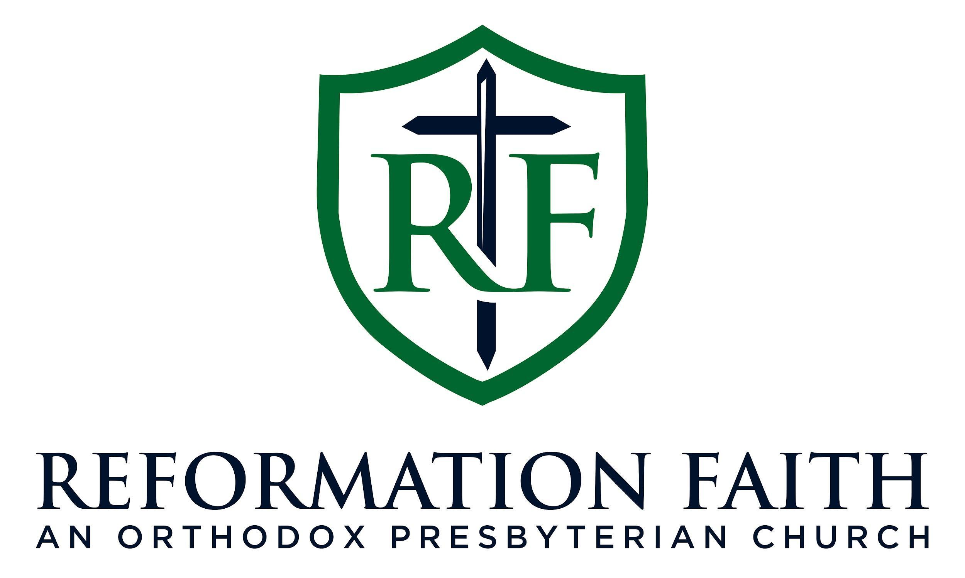

MORNING WORSHIP SERVICE

January 18th, 2026 9:00 A.M.

MORNING WORSHIP SERVICE

January 18th, 2026 9:00 A.M.

