Welcome and Announcements

PERCEIVING GOD’S GREATNESS

*Salutation
*Prayer of Invocation and Adoration
*Call to Worship Gen. 22:1,31:11; Ex.3:4; 1 Sam. 3:4; Isa. 6:8,43:1
*Song of Worship Hymn #241
Affirmation of Faith The Larger Catechism Question 24
*Song of Worship Hymn #350

PARALYZED BY GOD’S HOLINESS

Confession of Sin Romans 1:21-22

Confirmation of the Gospel Ephesians 4:17-24
Song of Worship Psalm 92A
Pastoral Prayer

PURIFIED BY GOD’S WORD & SPIRIT

*Scripture Reading Exodus 13
Sermon “Move forward Looking Back”
**The Lord’s Supper

PREPARED BY GOD TO SERVE

*Song of Response Hymn #488
Receiving New Members and Vows
*Benediction Ephesians 3:17-19
*Doxology Psalm 117B

“Praise the Lord God, all you nations; all you peoples, sing his praise. For his truth endures forever, and his steadfast love is great. He is faithful!(X2) Hallelujah! Praise the Lord!”
*Congregation standing as able.
**All bread is gluten free.

Welcome and Announcements

PERCEIVING GOD’S GREATNESS

*Salutation
*Prayer of Invocation and Adoration
*Call to Worship Gen. 22:1,31:11; Ex.3:4; 1 Sam. 3:4; Isa. 6:8,43:1
*Song of Worship Hymn #241
Affirmation of Faith The Larger Catechism Question 24
*Song of Worship Hymn #350

PARALYZED BY GOD’S HOLINESS

Confession of Sin Romans 1:21-22

Confirmation of the Gospel Ephesians 4:17-24
Song of Worship Psalm 92A
Pastoral Prayer

PURIFIED BY GOD’S WORD & SPIRIT

*Scripture Reading Exodus 13
Sermon “Move forward Looking Back”
**The Lord’s Supper

PREPARED BY GOD TO SERVE

*Song of Response Hymn #488
Receiving New Members and Vows
*Benediction Ephesians 3:17-19
*Doxology Psalm 117B

“Praise the Lord God, all you nations; all you peoples, sing his praise. For his truth endures forever, and his steadfast love is great. He is faithful!(X2) Hallelujah! Praise the Lord!”
*Congregation standing as able.
**All bread is gluten free.

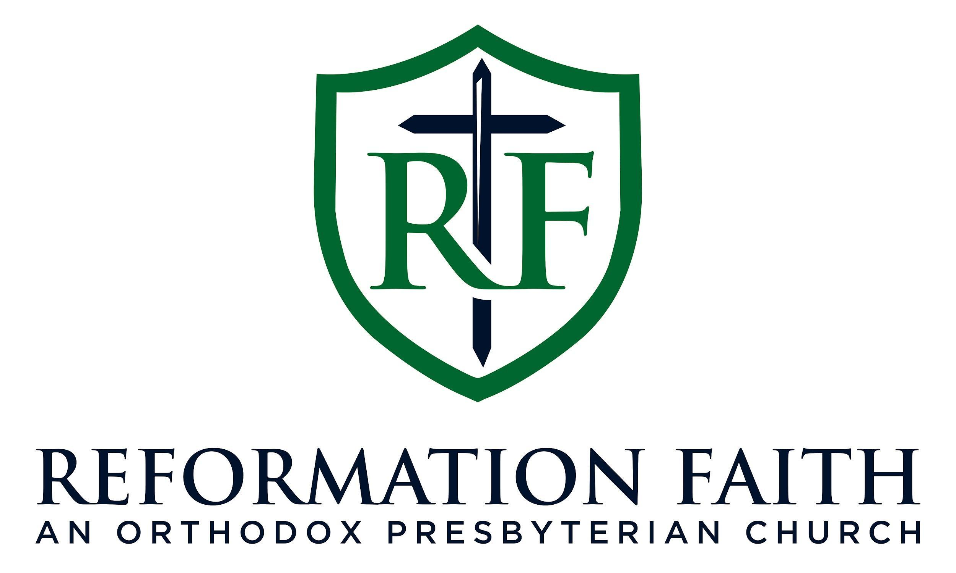

MORNING WORSHIP SERVICE

January 11th, 2026 9:00 A.M.

MORNING WORSHIP SERVICE

January 11th, 2026 9:00 A.M.

