Welcome and Announcements

PERCEIVING OUR GOD’S GREATNESS
*Salutation
*Prayer of Invocation and Adoration
*Call to Worship Isaiah 58:13-14

Turn back your foot from doing your pleasure on the Lord’s holy day, and call the Sabbath a delight and the holy day of the Lord honorable. Take delight in the Lord, and he will make you ride on the heights of the earth;
he will feed you with the heritage of Jacob your father.

*Song of Worship Hymn #303
*Affirmation of Faith Heidelberg #14 (page 874)
*Song of Worship Psalm 13

PARALYZED BY GOD’S HOLINESS

Confession of Sin Deuteronomy 5:8-10

Confirmation of the Gospel Phillipians 1:8
*Song of Worship Psalm 131B
**Pastoral Prayer

PURIFIED BY GOD’S WORD & SPIRIT
*New Testament Reading Titus 2:1-5
Sermon “High Mileage Saints”
***The Lord’s Supper

PREPARED BY GOD TO SERVE
*Song of Response Hymn #533
*Benediction Numbers 6:24-26
*Doxology Psalm 117B

“Praise the Lord God, all you nations; all you peoples, sing his praise. For his truth endures forever, and his steadfast love is great. He is faithful!(X2) Hallelujah! Praise the Lord!”

*Congregation standing as able.
** The Lord’s prayer is hymn #559
***All bread is gluten free.
Welcome and Announcements

PERCEIVING OUR GOD’S GREATNESS
*Salutation
*Prayer of Invocation and Adoration
*Call to Worship Isaiah 58:13-14

Turn back your foot from doing your pleasure on the Lord’s holy day, and call the Sabbath a delight and the holy day of the Lord honorable. Take delight in the Lord, and he will make you ride on the heights of the earth;
he will feed you with the heritage of Jacob your father.

*Song of Worship Hymn #303
*Affirmation of Faith Heidelberg #14 (page 874)
*Song of Worship Psalm 13

PARALYZED BY GOD’S HOLINESS

Confession of Sin Deuteronomy 5:8-10

Confirmation of the Gospel Phillipians 1:8
*Song of Worship Psalm 131B
**Pastoral Prayer

PURIFIED BY GOD’S WORD & SPIRIT
*New Testament Reading Titus 2:1-5
Sermon “High Mileage Saints”
***The Lord’s Supper

PREPARED BY GOD TO SERVE
*Song of Response Hymn #533
*Benediction Numbers 6:24-26
*Doxology Psalm 117B

“Praise the Lord God, all you nations; all you peoples, sing his praise. For his truth endures forever, and his steadfast love is great. He is faithful!(X2) Hallelujah! Praise the Lord!”

*Congregation standing as able.
** The Lord’s prayer is hymn #559
***All bread is gluten free.

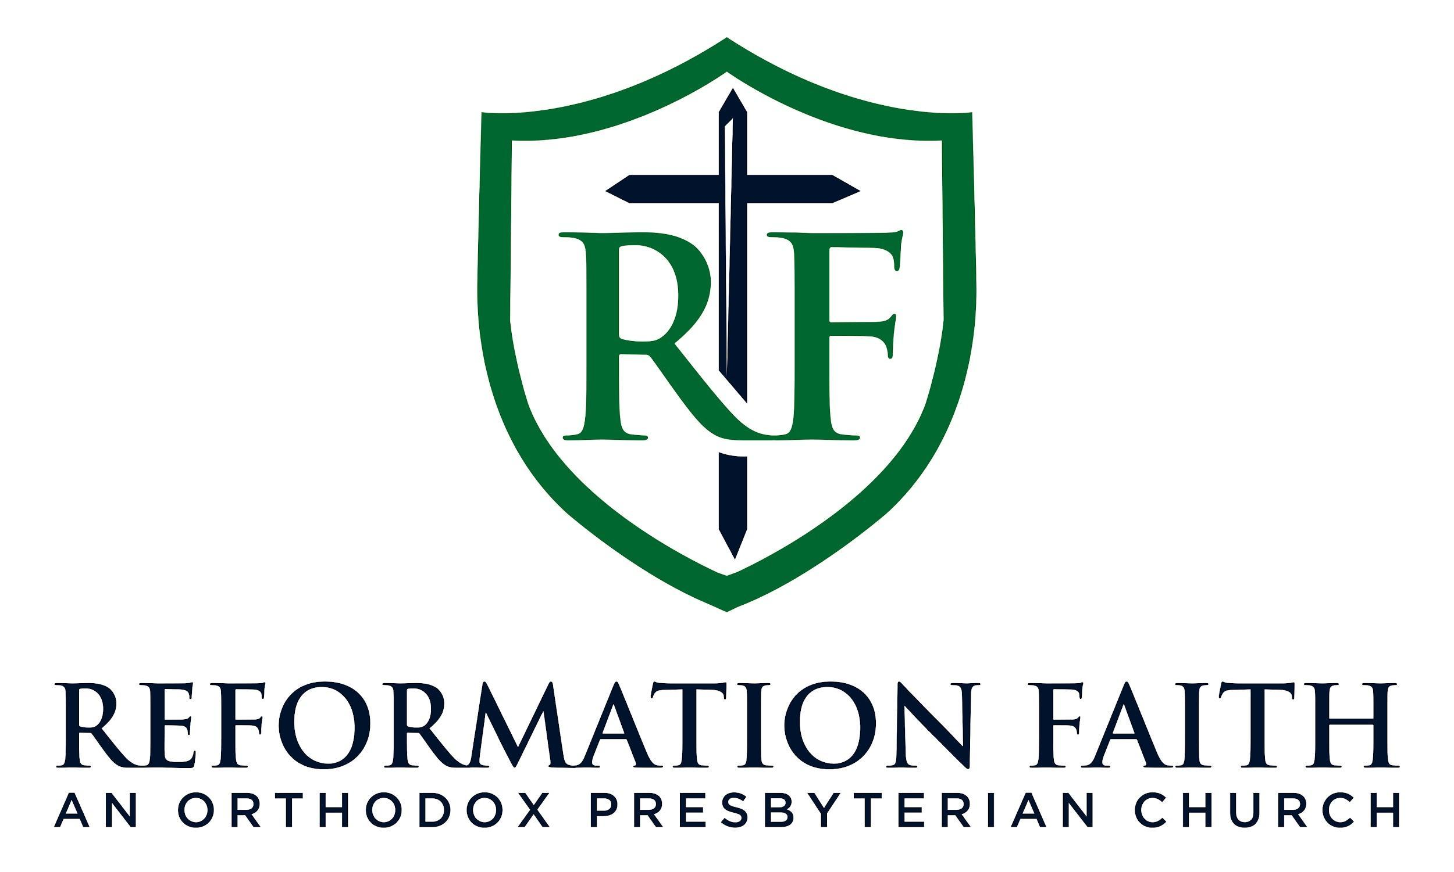

EVENING WORSHIP SERVICE

January 25th, 2026
4:00 P.M.

EVENING WORSHIP SERVICE

January 25th, 2026
4:00 P.M.

