Welcome and Announcements

PERCEIVING OUR GOD’S GREATNESS
*Salutation
*Prayer of Invocation and Adoration
*Call to Worship Isaiah 45:1,20,22,23

Thus says the Lord, “Assemble yourselves and come; draw near together; turn to me and be saved, all the ends of the earth! For I am God, and there is no other. To me every knee shall bow, every tongue shall swear allegiance.”

*Song of Worship Hymn #496
*Affirmation of Faith Heidelberg #13 (page 874)
*Song of Worship Psalm 12

PARALYZED BY GOD’S HOLINESS

Confession of Sin Deuteronomy 5:7

Confirmation of the Gospel Phillipians 1:7
*Song of Worship Psalm 130A
Pastoral Prayer

PURIFIED BY GOD’S WORD & SPIRIT
*New Testament Reading Titus 1:10-16
Sermon “Ordinary Redefined: Hurt to Heal”
**The Lord’s Supper

PREPARED BY GOD TO SERVE
*Song of Response Hymn #184
Receiving New Members and Vows
*Benediction Numbers 6:24-26
*Doxology Psalm 117B

“Praise the Lord God, all you nations; all you peoples, sing his praise. For his truth endures forever, and his steadfast love is great. He is faithful!(X2) Hallelujah! Praise the Lord!”

*Congregation standing as able.
**All bread is gluten free.

Welcome and Announcements

PERCEIVING OUR GOD’S GREATNESS
*Salutation
*Prayer of Invocation and Adoration
*Call to Worship Isaiah 45:1,20,22,23

Thus says the Lord, “Assemble yourselves and come; draw near together; turn to me and be saved, all the ends of the earth! For I am God, and there is no other. To me every knee shall bow, every tongue shall swear allegiance.”

*Song of Worship Hymn #496
*Affirmation of Faith Heidelberg #13 (page 874)
*Song of Worship Psalm 12

PARALYZED BY GOD’S HOLINESS

Confession of Sin Deuteronomy 5:7

Confirmation of the Gospel Phillipians 1:7
*Song of Worship Psalm 130A
Pastoral Prayer

PURIFIED BY GOD’S WORD & SPIRIT
*New Testament Reading Titus 1:10-16
Sermon “Ordinary Redefined: Hurt to Heal”
**The Lord’s Supper

PREPARED BY GOD TO SERVE
*Song of Response Hymn #184
Receiving New Members and Vows
*Benediction Numbers 6:24-26
*Doxology Psalm 117B

“Praise the Lord God, all you nations; all you peoples, sing his praise. For his truth endures forever, and his steadfast love is great. He is faithful!(X2) Hallelujah! Praise the Lord!”

*Congregation standing as able.
**All bread is gluten free.

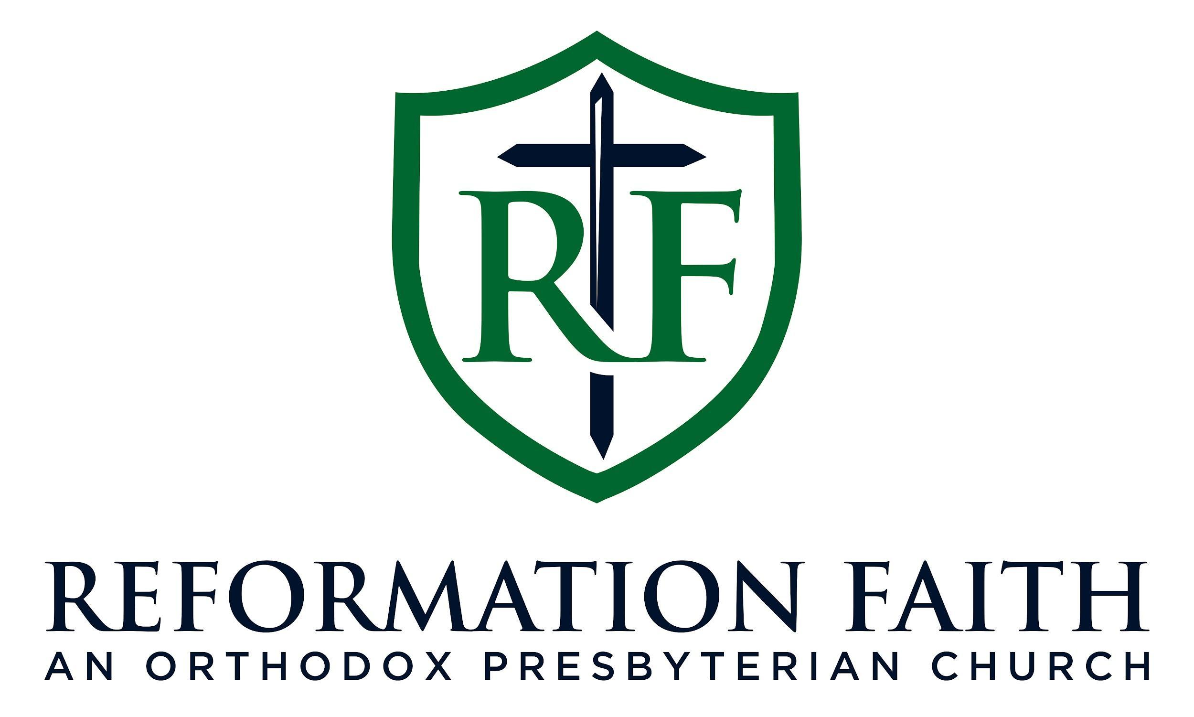

EVENING WORSHIP SERVICE

January 18th, 2026
3:00 P.M.

EVENING WORSHIP SERVICE

January 18th, 2026
3:00 P.M.

