Welcome and Announcements

PERCEIVING OUR GOD’S GREATNESS
*Salutation
*Prayer of Invocation and Adoration
*Call to Worship Isaiah 44:23

Sing, O heavens, for the Lord has done it: shout, O depths of the earth: break forth into singing, O mountains, O forest, and every tree in it! For the Lord has redeemed Jacob, and will be glorified in Israel.
*Song of Worship Hymn #239
*Affirmation of Faith Heidelberg #12 (page 874)
*Song of Worship Psalm 37 vv. 1-5

PARALYZED BY GOD’S HOLINESS

Confession of Sin Deuteronomy 5:6

Confirmation of the Gospel Phillipians 1:6
*Song of Worship Psalm 37 vv. 6-10
Pastoral Prayer

PURIFIED BY GOD’S WORD & SPIRIT
*New Testament Reading Titus 1:5-9
Sermon “Ordinary Redefined: Leadership Part 2”

PREPARED BY GOD TO SERVE
*Song of Response Hymn #420
Receiving New Members and Vows
*Benediction
*Doxology Psalm 117B

“Praise the Lord God, all you nations; all you peoples, sing his praise. For his truth endures forever, and his steadfast love is great. He is faithful!(X2) Hallelujah! Praise the Lord!”

*Congregation standing as able.

Welcome and Announcements

PERCEIVING OUR GOD’S GREATNESS
*Salutation
*Prayer of Invocation and Adoration
*Call to Worship Isaiah 44:23

Sing, O heavens, for the Lord has done it: shout, O depths of the earth: break forth into singing, O mountains, O forest, and every tree in it! For the Lord has redeemed Jacob, and will be glorified in Israel.
*Song of Worship Hymn #239
*Affirmation of Faith Heidelberg #12 (page 874)
*Song of Worship Psalm 37 vv. 1-5

PARALYZED BY GOD’S HOLINESS

Confession of Sin Deuteronomy 5:6

Confirmation of the Gospel Phillipians 1:6
*Song of Worship Psalm 37 vv. 6-10
Pastoral Prayer

PURIFIED BY GOD’S WORD & SPIRIT
*New Testament Reading Titus 1:5-9
Sermon “Ordinary Redefined: Leadership Part 2”

PREPARED BY GOD TO SERVE
*Song of Response Hymn #420
Receiving New Members and Vows
*Benediction
*Doxology Psalm 117B

“Praise the Lord God, all you nations; all you peoples, sing his praise. For his truth endures forever, and his steadfast love is great. He is faithful!(X2) Hallelujah! Praise the Lord!”

*Congregation standing as able.

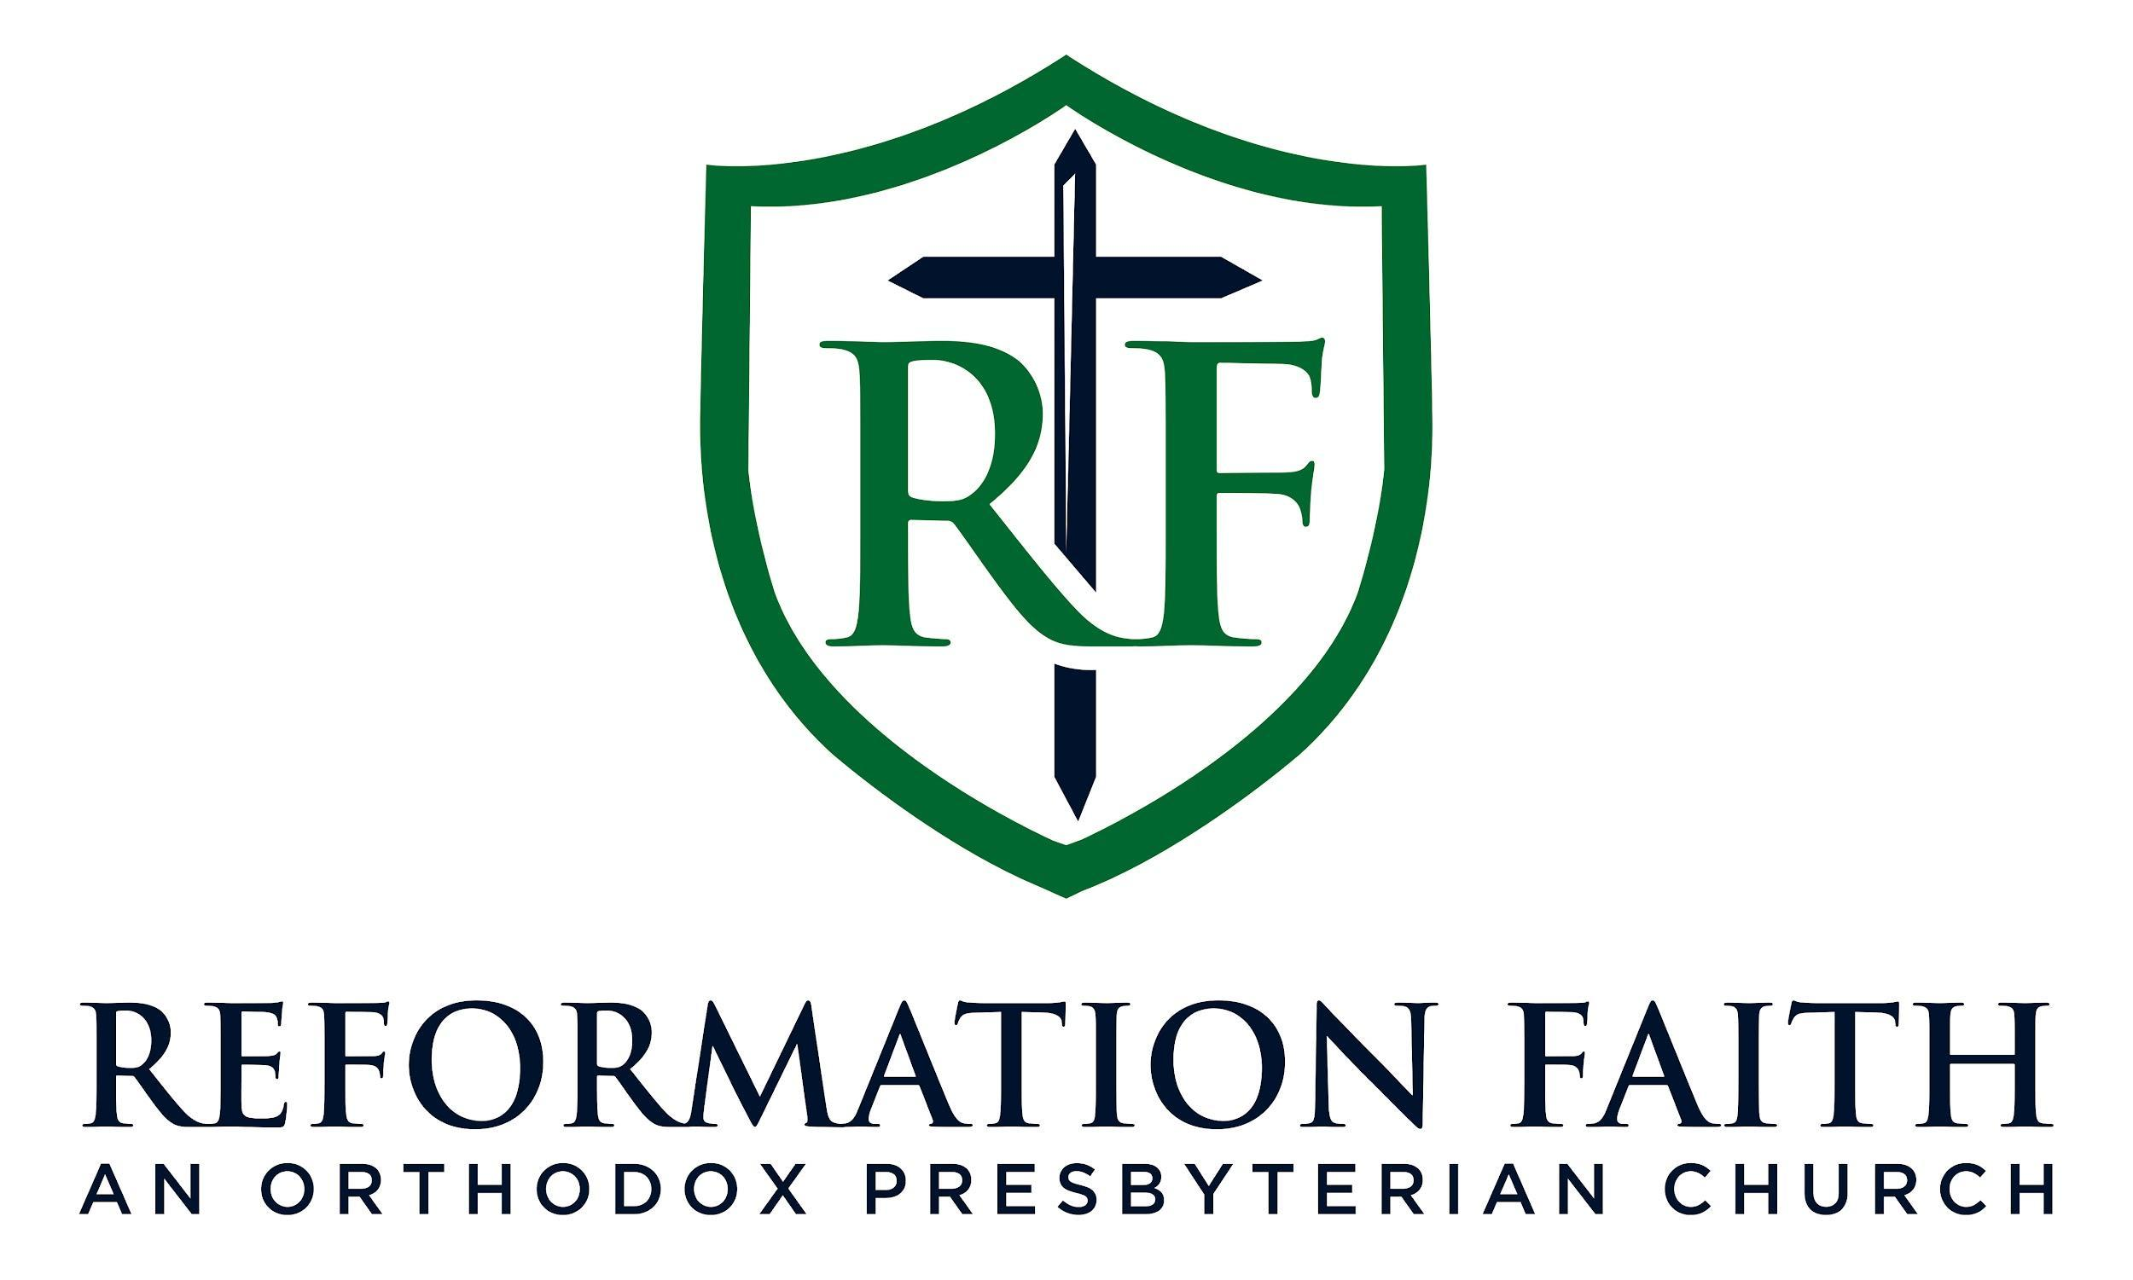

EVENING WORSHIP SERVICE

January 11th, 2026
3:00 P.M.

EVENING WORSHIP SERVICE

January 11th, 2026
3:00 P.M.

