Welcome and Announcements

PERCEIVING GOD’S GREATNESS

*Salutation
*Prayer of Invocation and Adoration
*Call to Worship Psalm 8:1-9
*Song of Worship Hymn #293
*Affirmation of Faith Nicene Creed (page 852)
*Song of Worship Psalm 54

PARALYZED BY GOD’S HOLINESS

Confession of Sin Romans 1:17

Confirmation of the Gospel Romans 1:17
Song of Worship Hymn #311
Pastoral Prayer

PURIFIED BY GOD’S WORD & SPIRIT

*Scripture Reading Exodus 11
Sermon “Highly Favored”
**The Lord’s Supper

PREPARED BY GOD TO SERVE

*Song of Response Hymn #299
*Benediction
*Doxology Psalm 117B

“Praise the Lord God, all you nations; all you peoples, sing his praise. For his truth endures forever, and his steadfast love is great. He is faithful!(X2) Hallelujah! Praise the Lord!”

*Congregation standing as able.
**All bread is gluten free.

Welcome and Announcements

PERCEIVING GOD’S GREATNESS

*Salutation
*Prayer of Invocation and Adoration
*Call to Worship Psalm 8:1-9
*Song of Worship Hymn #293
*Affirmation of Faith Nicene Creed (page 852)
*Song of Worship Psalm 54

PARALYZED BY GOD’S HOLINESS

Confession of Sin Romans 1:17

Confirmation of the Gospel Romans 1:17
Song of Worship Hymn #311
Pastoral Prayer

PURIFIED BY GOD’S WORD & SPIRIT

*Scripture Reading Exodus 11
Sermon “Highly Favored”
**The Lord’s Supper

PREPARED BY GOD TO SERVE

*Song of Response Hymn #299
*Benediction
*Doxology Psalm 117B

“Praise the Lord God, all you nations; all you peoples, sing his praise. For his truth endures forever, and his steadfast love is great. He is faithful!(X2) Hallelujah! Praise the Lord!”

*Congregation standing as able.
**All bread is gluten free.

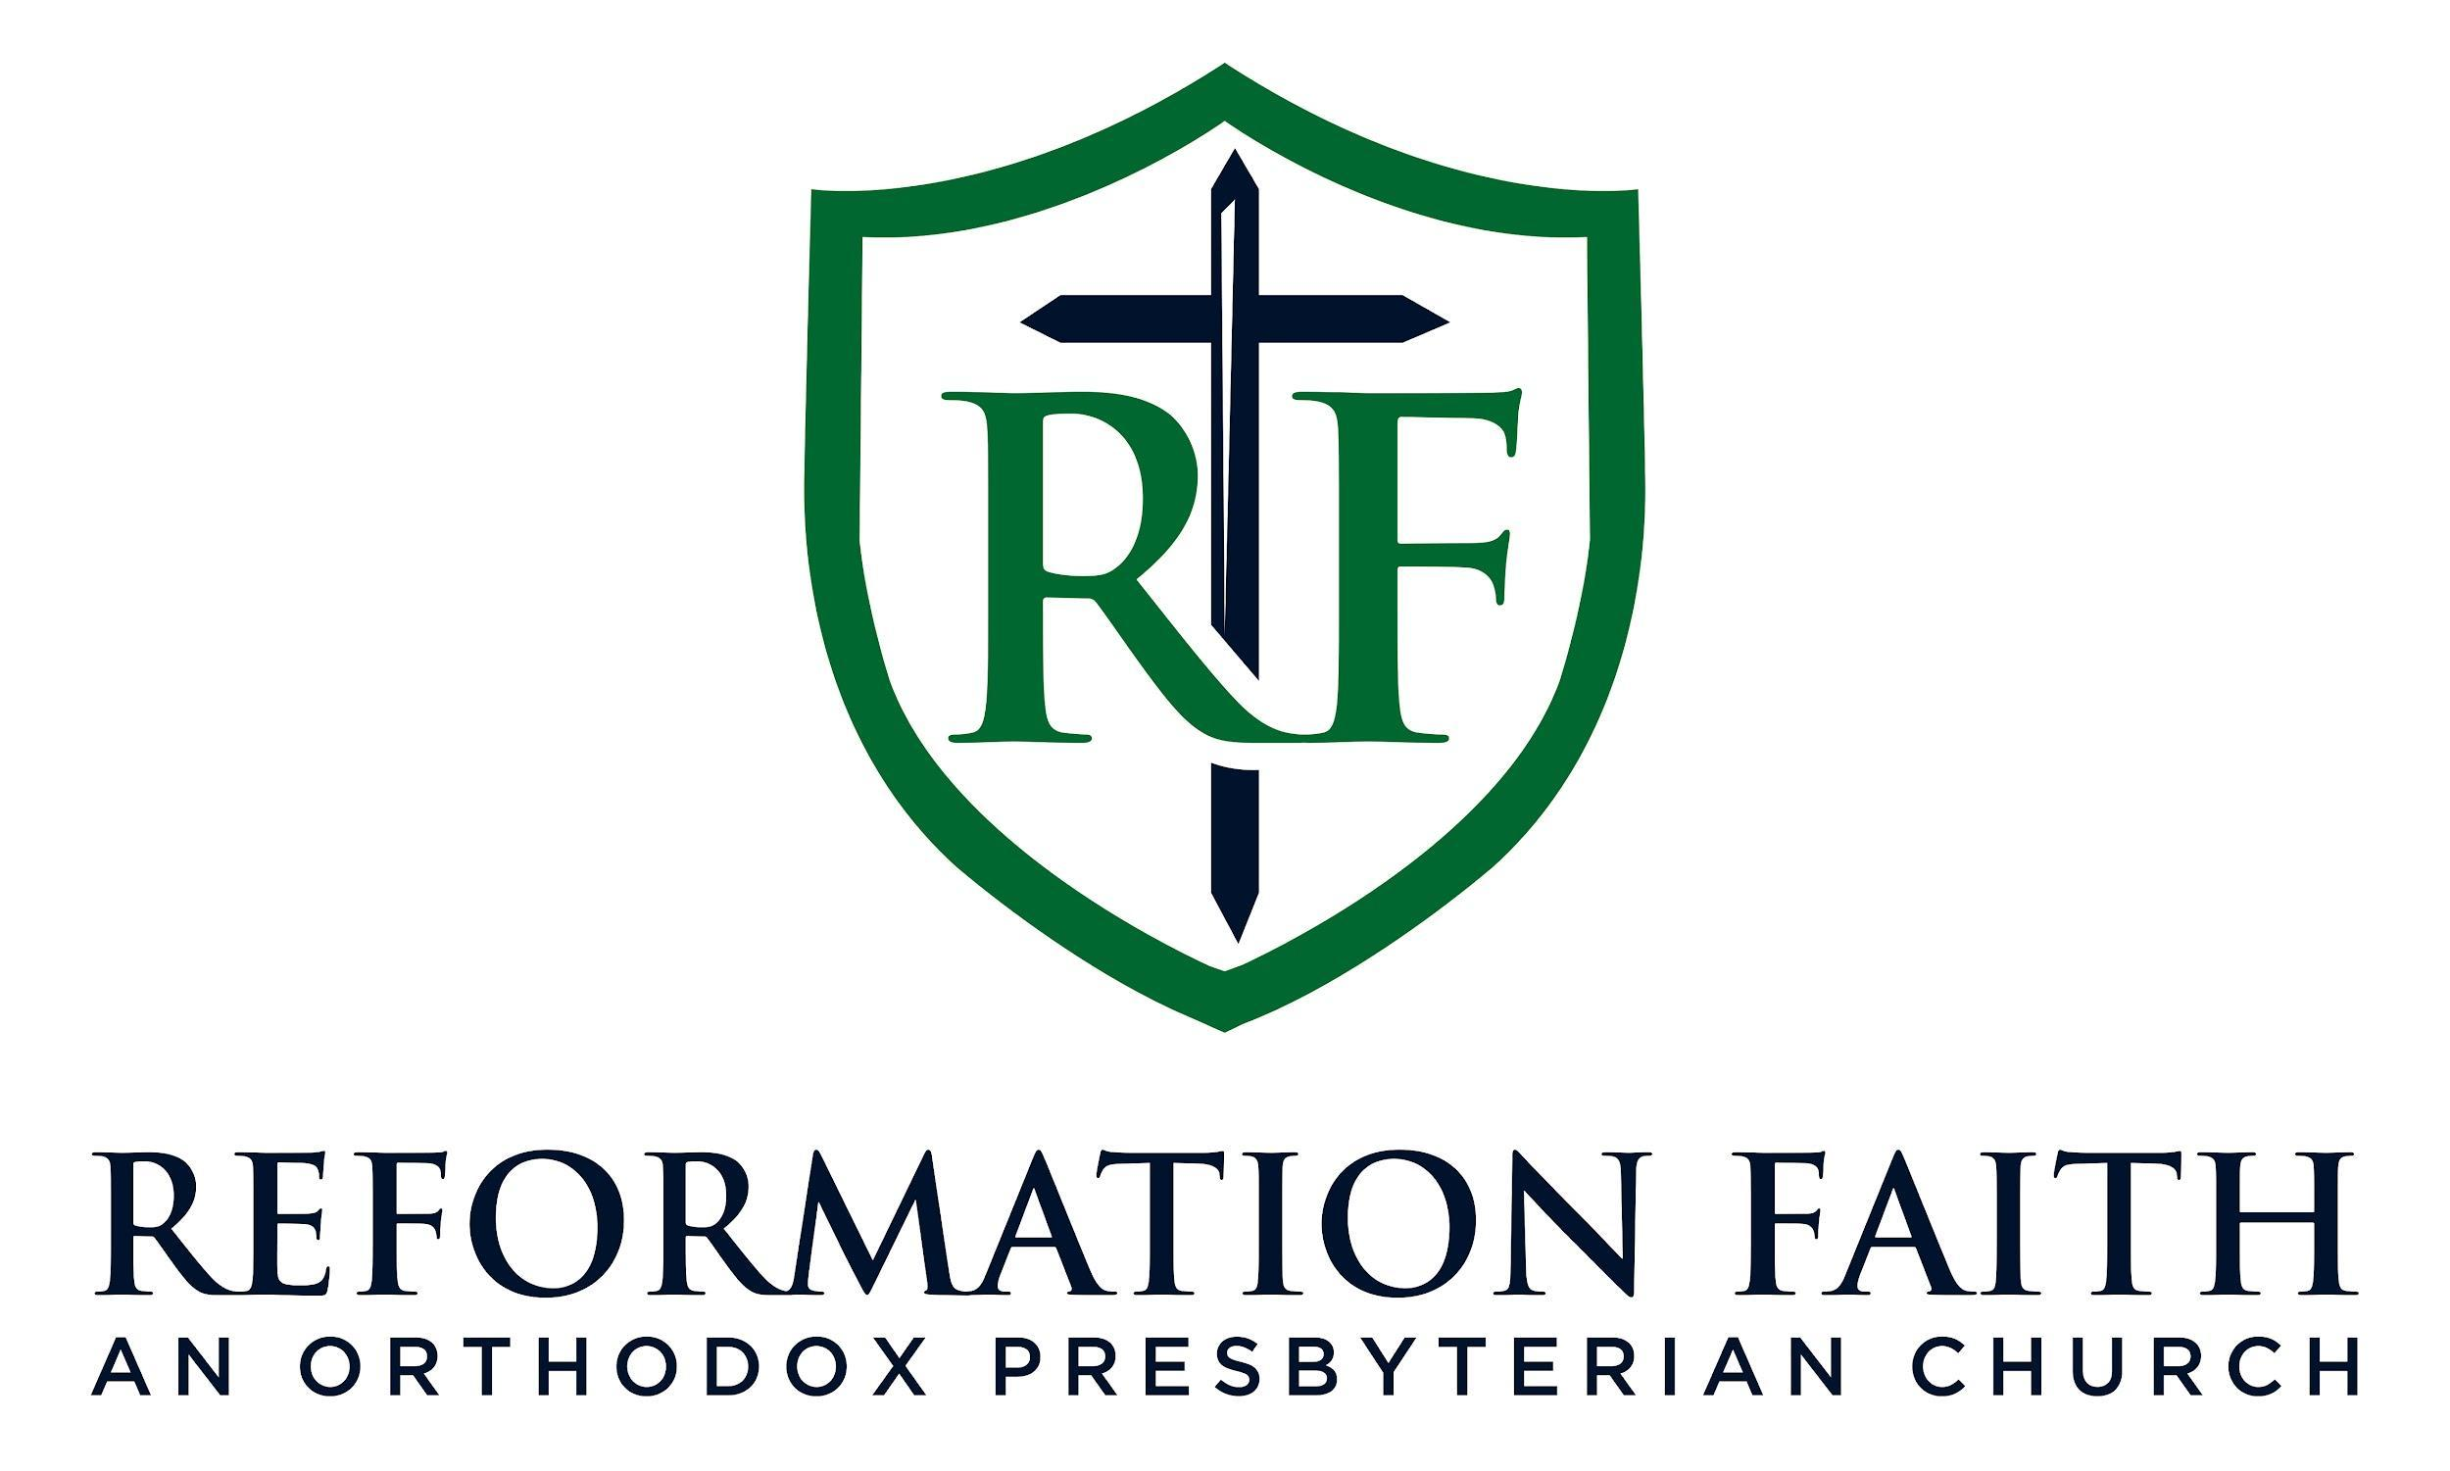

MORNING WORSHIP SERVICE

December 21st, 2025 9:00 A.M.

MORNING WORSHIP SERVICE

December 21st, 2025 9:00 A.M.

