Welcome and Announcements

PERCEIVING OUR GOD’S GREATNESS
*Salutation
*Prayer of Invocation and Adoration
*Call to Worship Isaiah 12:6

Go on up to a high mountain, O Zion, herald of good news; lift up your voice with strength, O Jerusalem, herald of good news; lift it up, fear not; say to the cities of Judah, “Behold your God!”
*Song of Worship Hymn #318
*Affirmation of Faith Heidelberg #9 (page 873)

Pastor:
But doesn’t God do us an injustice by requiring in his law what we are unable to do?

Congregation:
No, God created human beings with the ability to keep the law.
They, however, provoked by the devil, in willful disobedience,
robbed themselves and all their descendants of these gifts.

PARALYZED BY GOD’S HOLINESS
*Song of Worship Psalm 36b Pastoral Prayer

PURIFIED BY GOD’S WORD & SPIRIT
*New Testament Reading Titus 1:5-9
Sermon “Leadership: Part One”

PREPARED BY GOD TO SERVE
*Song of Response Hymn #320
*Benediction
*Doxology Psalm 117B

“Praise the Lord God, all you nations; all you peoples, sing his praise. For his truth endures forever, and his steadfast love is great. He is faithful!(X2) Hallelujah! Praise the Lord!”
*Congregation standing as able.

Welcome and Announcements

PERCEIVING OUR GOD’S GREATNESS
*Salutation
*Prayer of Invocation and Adoration
*Call to Worship Isaiah 12:6

Go on up to a high mountain, O Zion, herald of good news; lift up your voice with strength, O Jerusalem, herald of good news; lift it up, fear not; say to the cities of Judah, “Behold your God!”
*Song of Worship Hymn #318
*Affirmation of Faith Heidelberg #9 (page 873)

Pastor:
But doesn’t God do us an injustice by requiring in his law what we are unable to do?

Congregation:
No, God created human beings with the ability to keep the law.
They, however, provoked by the devil, in willful disobedience,
robbed themselves and all their descendants of these gifts.

PARALYZED BY GOD’S HOLINESS
*Song of Worship Psalm 36b Pastoral Prayer

PURIFIED BY GOD’S WORD & SPIRIT
*New Testament Reading Titus 1:5-9
Sermon “Leadership: Part One”

PREPARED BY GOD TO SERVE
*Song of Response Hymn #320
*Benediction
*Doxology Psalm 117B

“Praise the Lord God, all you nations; all you peoples, sing his praise. For his truth endures forever, and his steadfast love is great. He is faithful!(X2) Hallelujah! Praise the Lord!”
*Congregation standing as able.

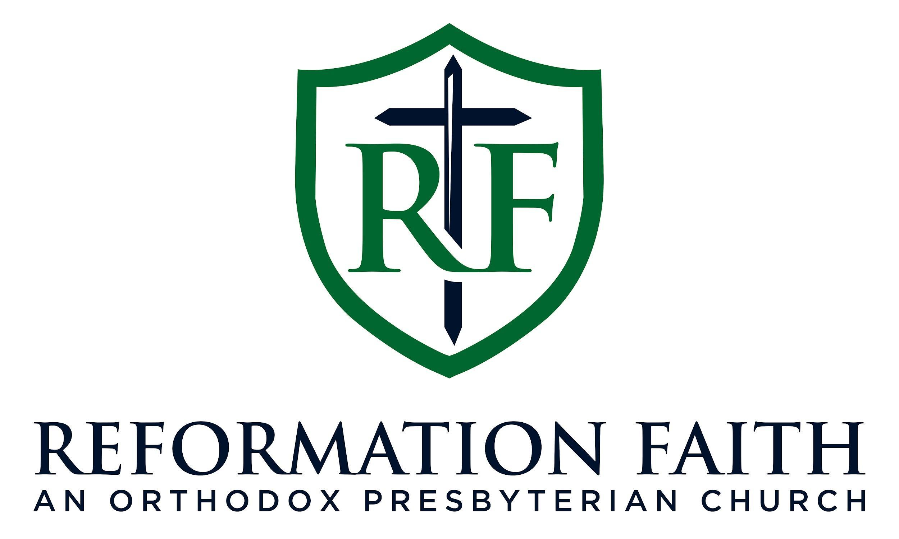

EVENING WORSHIP SERVICE

December 21st, 2025 3:00 P.M.

EVENING WORSHIP SERVICE

December 21st, 2025 3:00 P.M.

